<https://www.youtube.com/watch?v=oRrKeUCEbq8&list=PLblh5JKOoLUICTaGLRoHQDuF_7q2GfuJF&index=62>

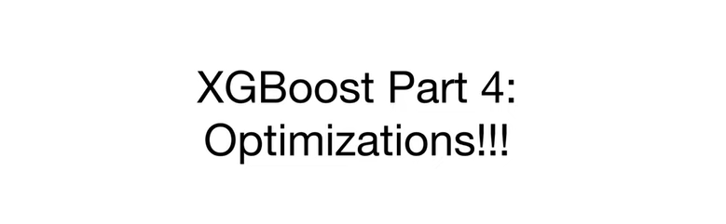

Today we're going to talk about XGBoost, part 4, optimizations.

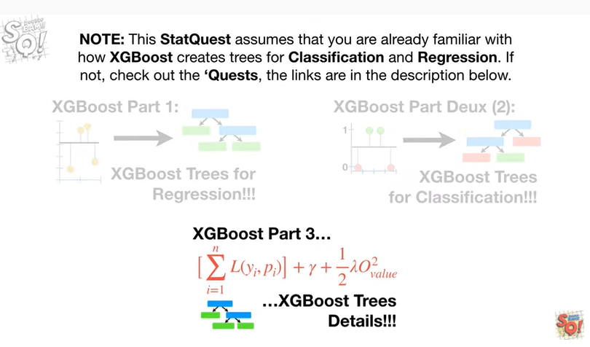

Note : this stack quest assumes that you are already familiar with how XGBoost creates trees for classification and regression, if not check out the quests.

The links are in the description below.

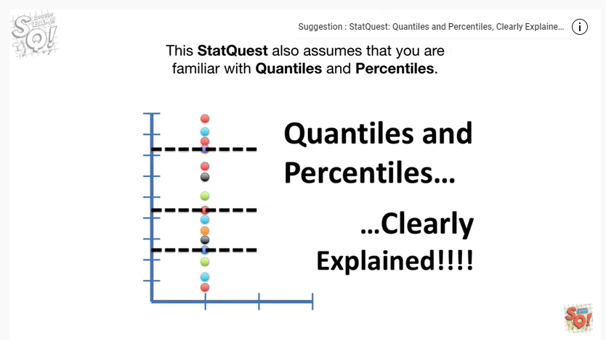

This stack west also assumes that you are familiar with quantiles and percentiles, if not check out the ques.

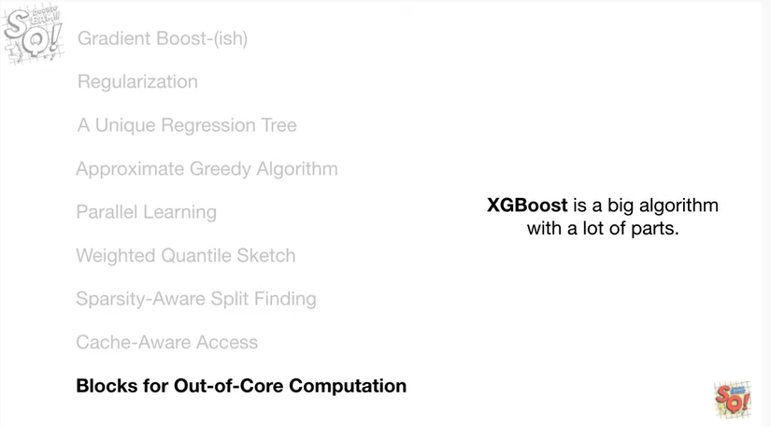

XGBoost is a big algorithm with a lot of parts.

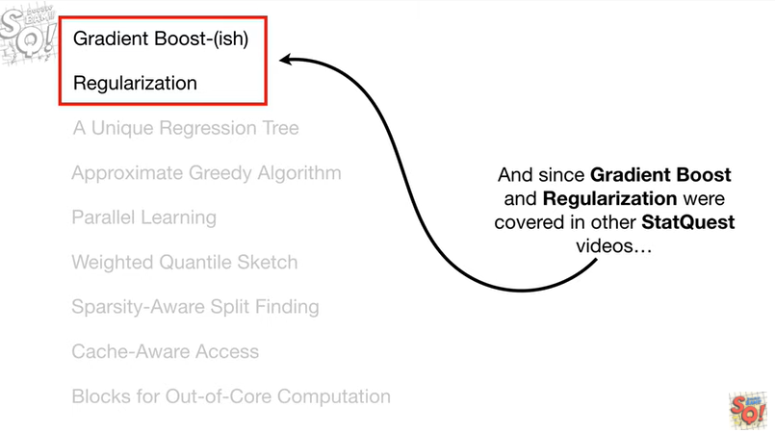

And since gradient boost and regularization were covered in other stat quest videos

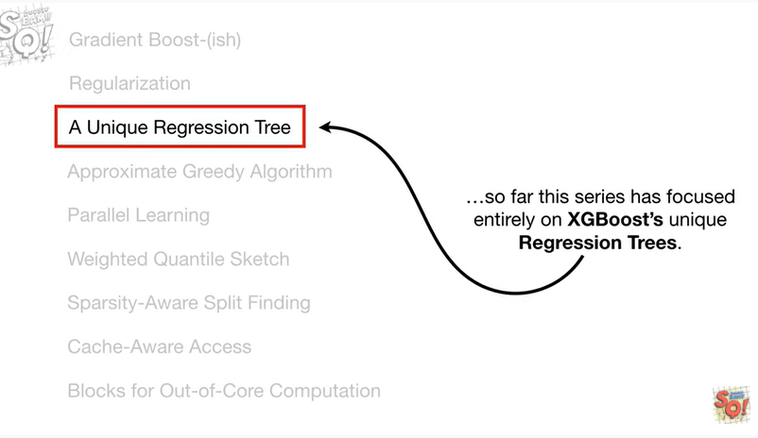

so far this series has focused entirely on XGBoosts unique regression trees.

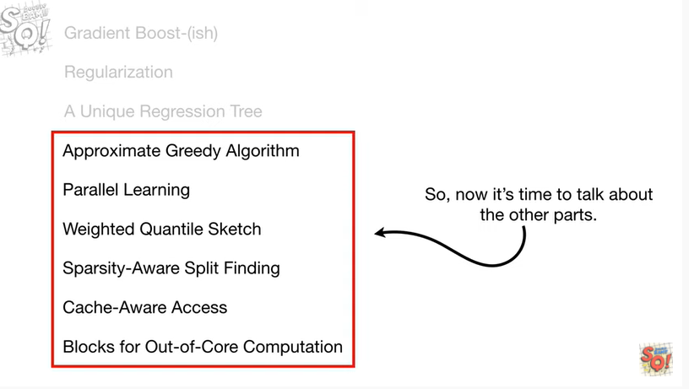

So now it's time to talk about the other parts.

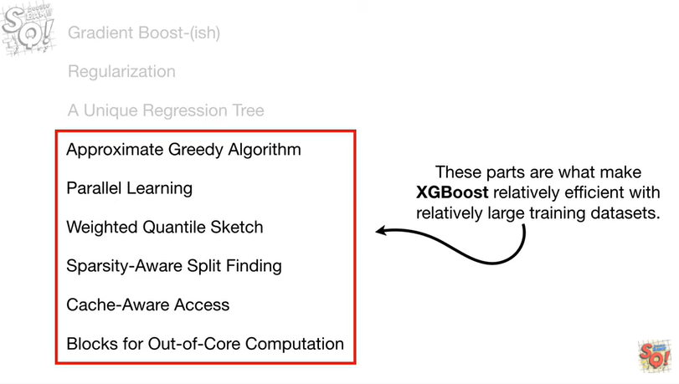

These parts are what make XGBoost relatively efficient with relatively large training data sets.

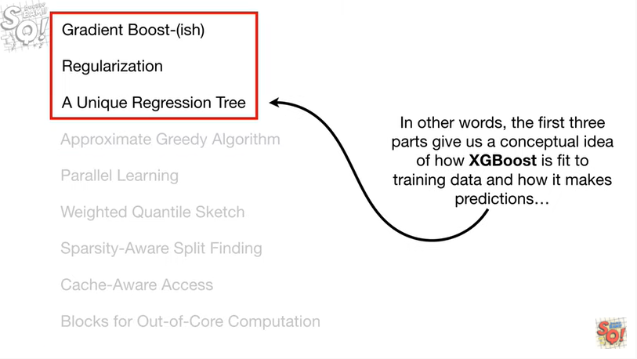

In other words, the first three parts give us a conceptual idea of how XGBoost is fit to training data and how it makes predictions

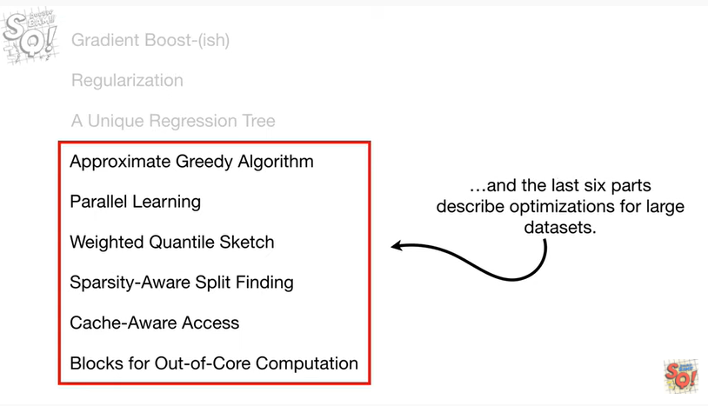

and the last six parts describe optimizations for large data sets.

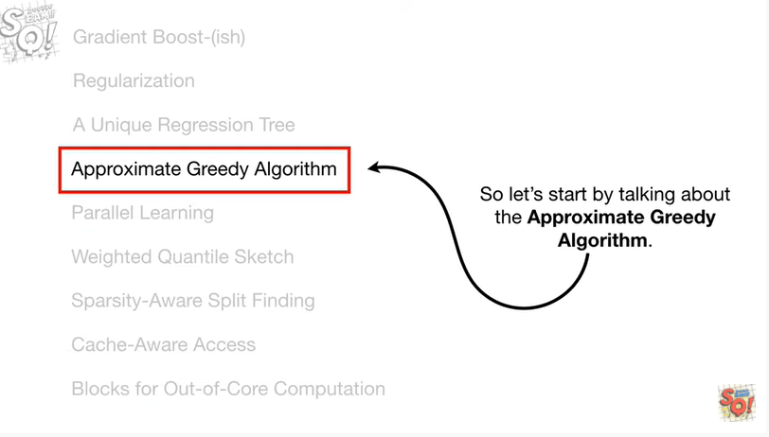

So let's start by talking about the approximate greedy algorithm.

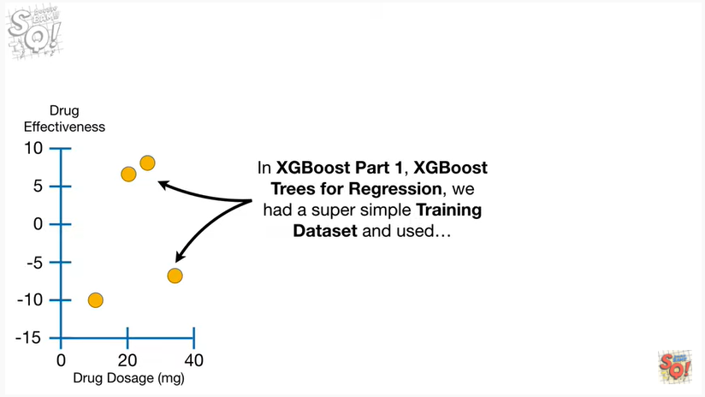

In XGBoost part 1, XGBoost trees for regression, we had a super simple training data set

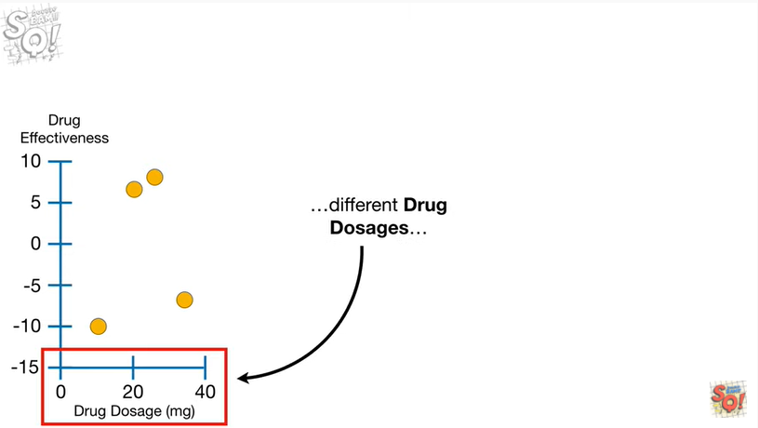

and used different drug dosages

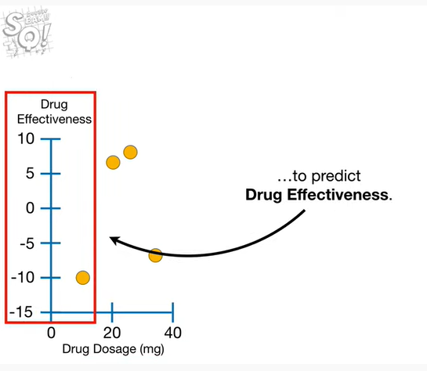

to predict drug effectiveness.

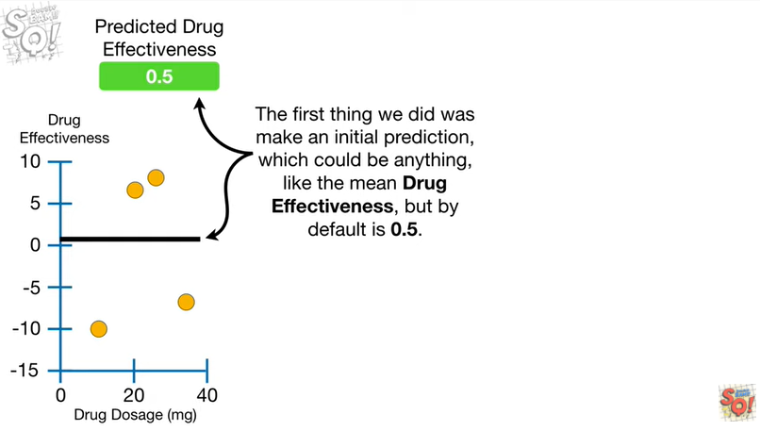

The first thing we did was make an initial prediction which could be anything, like the mean drug effectiveness, but by default is 0.5.

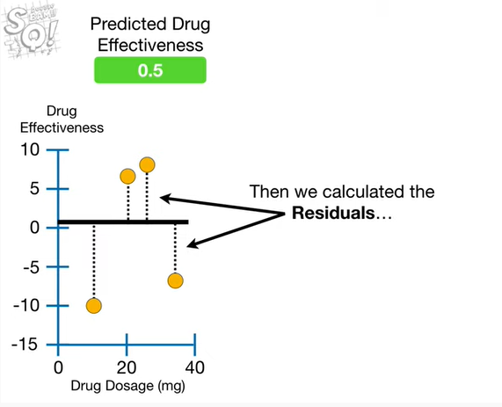

Then we calculated the residuals

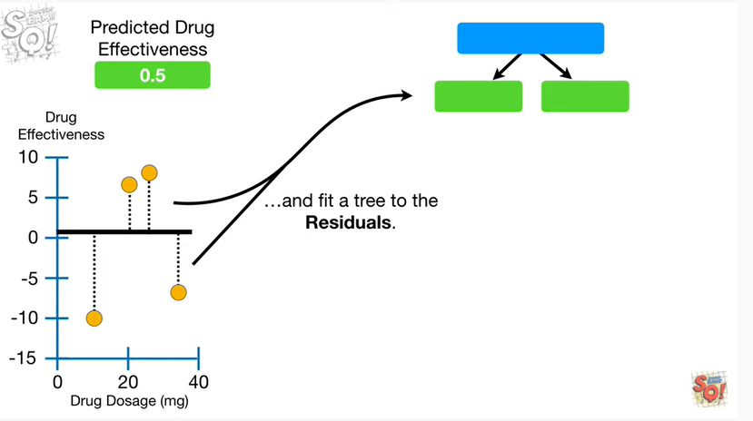

and fit a tree to the residuals.

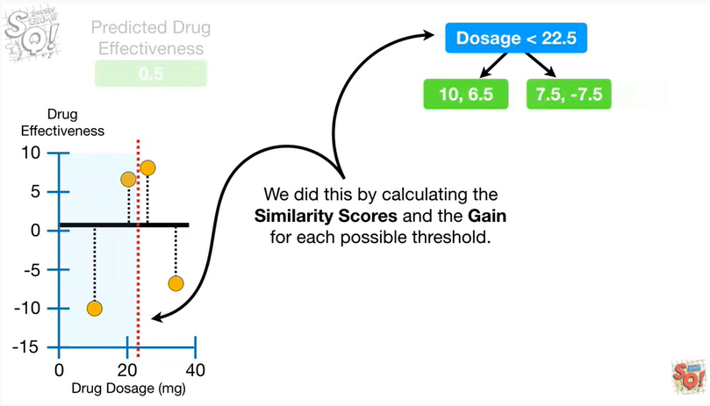

We did this by calculating similarity scores and the gain for each possible threshold.

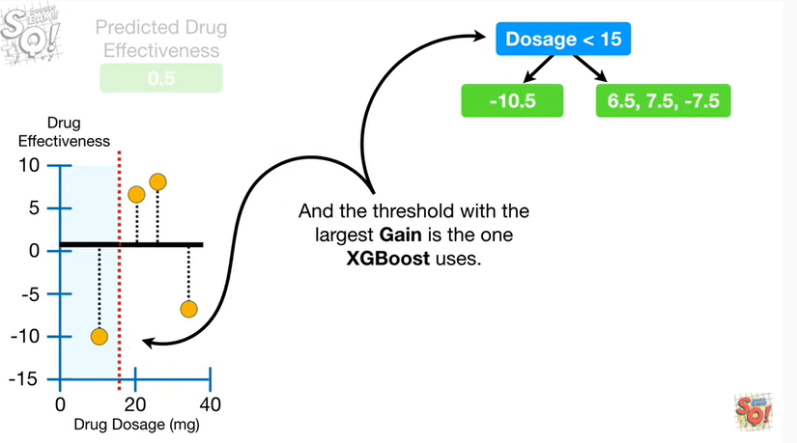

And the threshold with the largest gain is the one XGBoost uses.

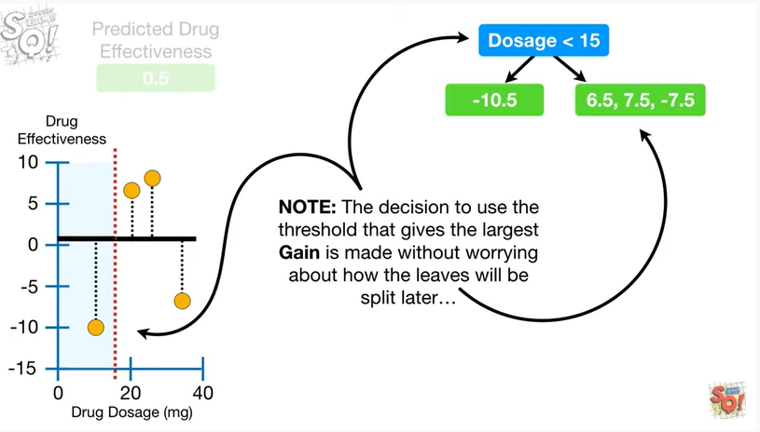

Note : the decision to use the threshold that gives the largest gain is made without worrying about how the leaves will be split later

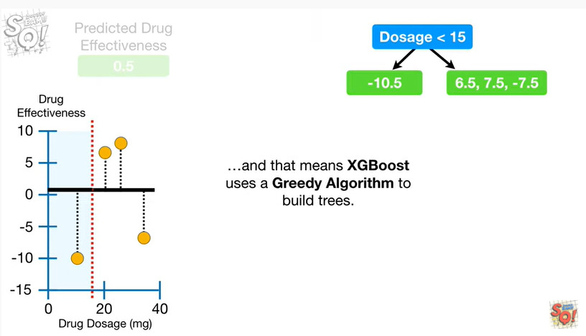

and that means XGBoost uses a greedy algorithm to build trees.

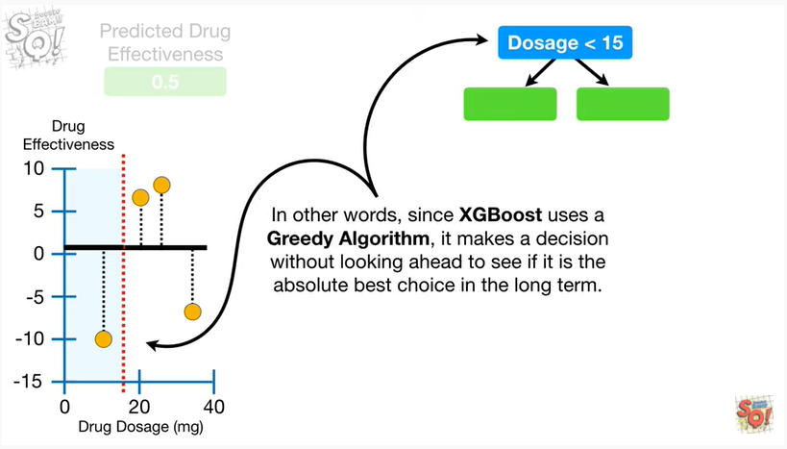

In other words, since XGBoost uses a greedy algorithm, it makes a decision without looking ahead to see if it is the absolute best choice in the long term.

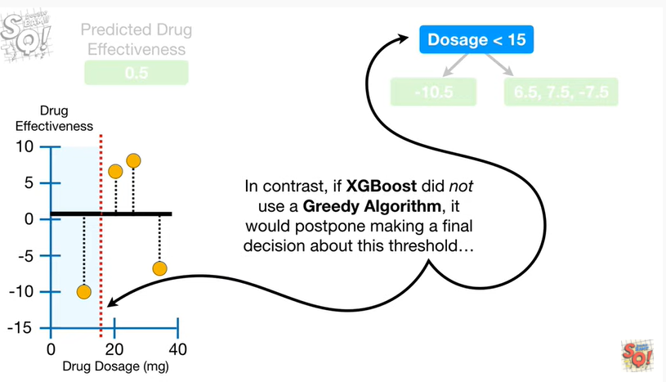

In contrast, if XGBoost did not use a greedy algorithm, it would postpone making a final decision about this threshold

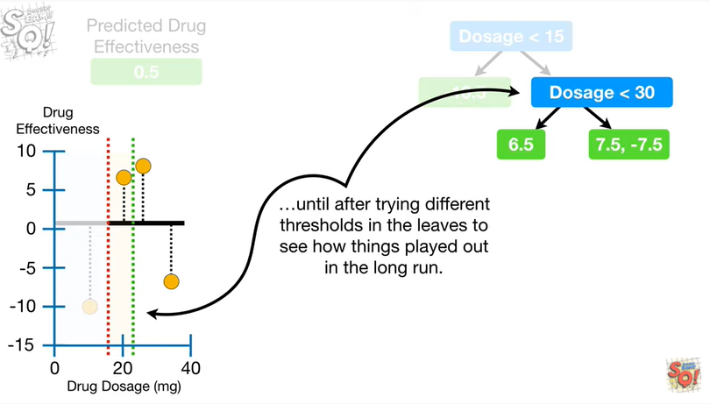

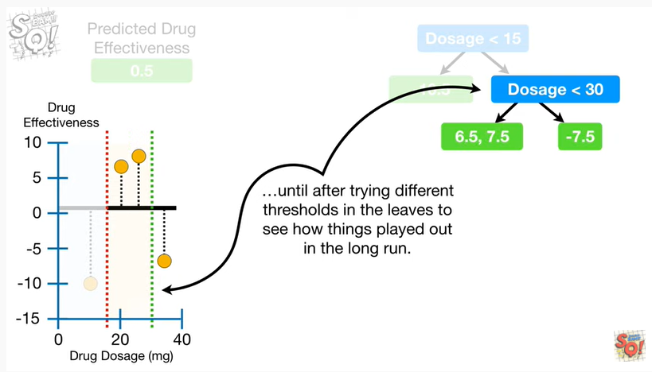

until after trying different thresholds in the leaves to see how things played out in the long run.

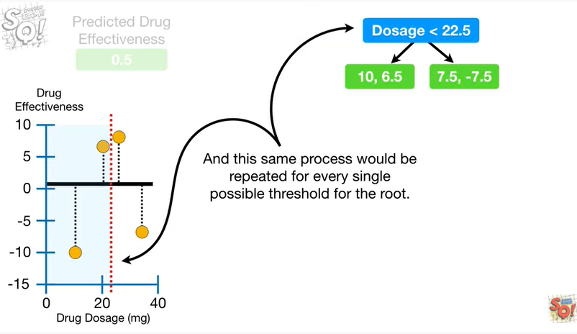

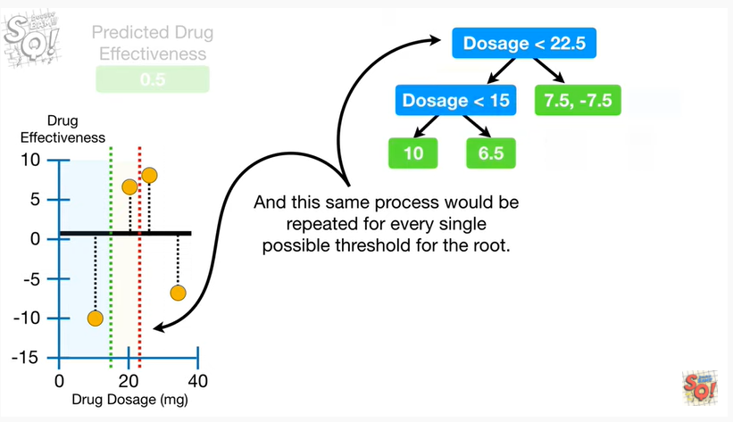

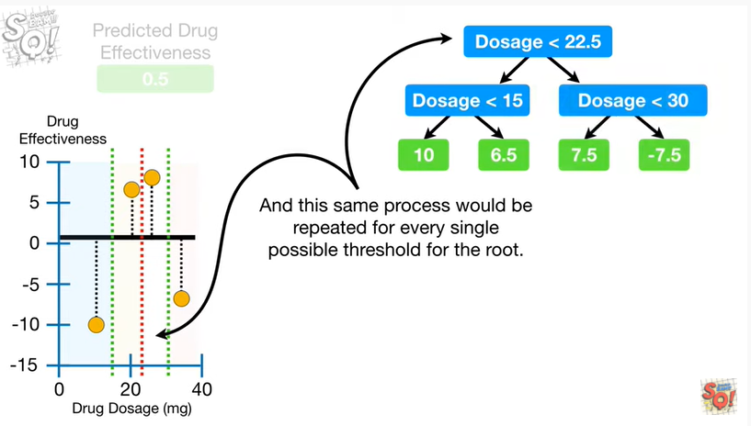

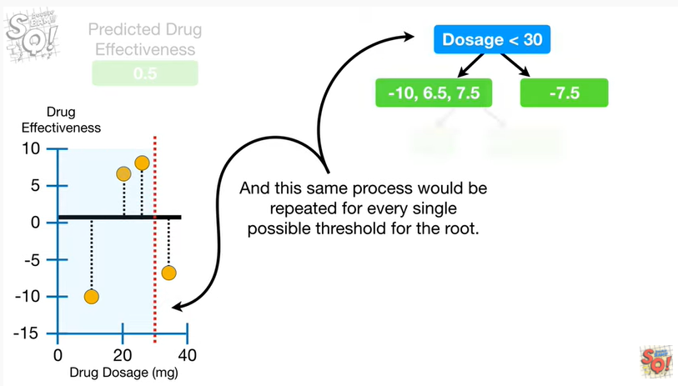

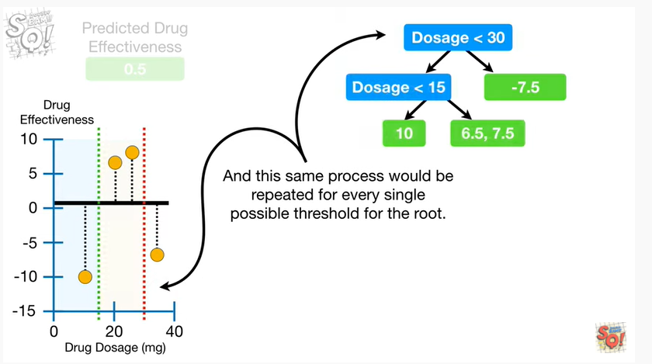

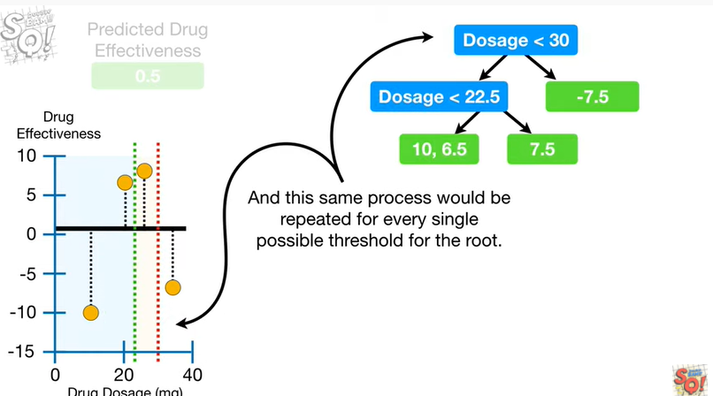

And this same process would be repeated for every single possible threshold for the root.

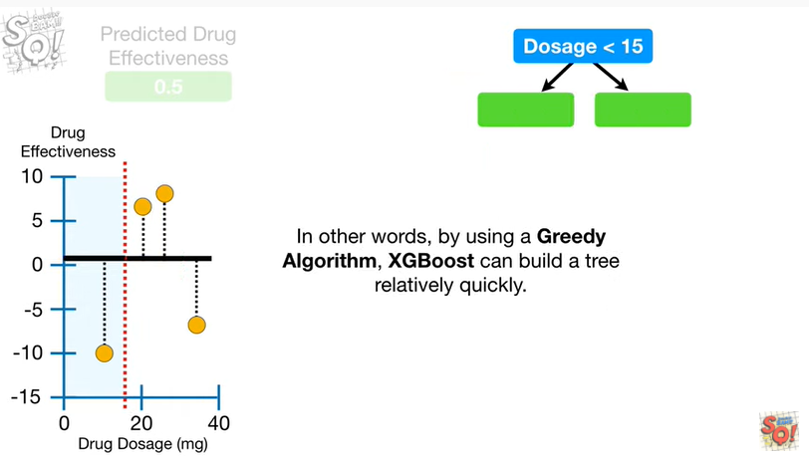

In other words, by using a greedy algorithm, XGBoost can build a tree relatively quickly.

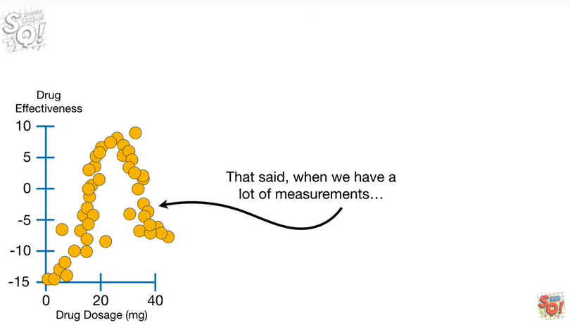

That said, when we have a lot of measurements

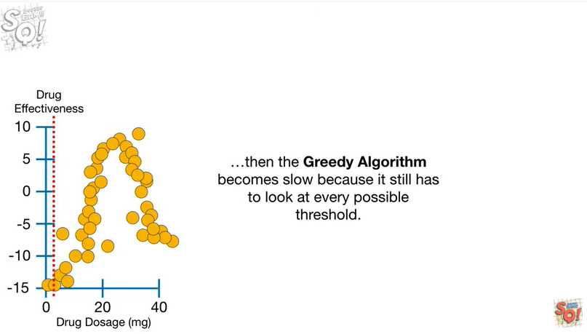

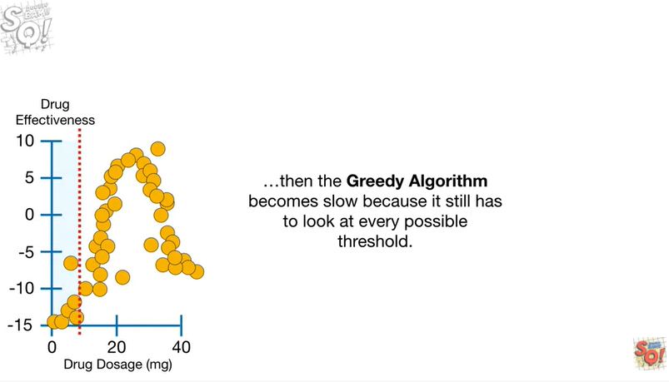

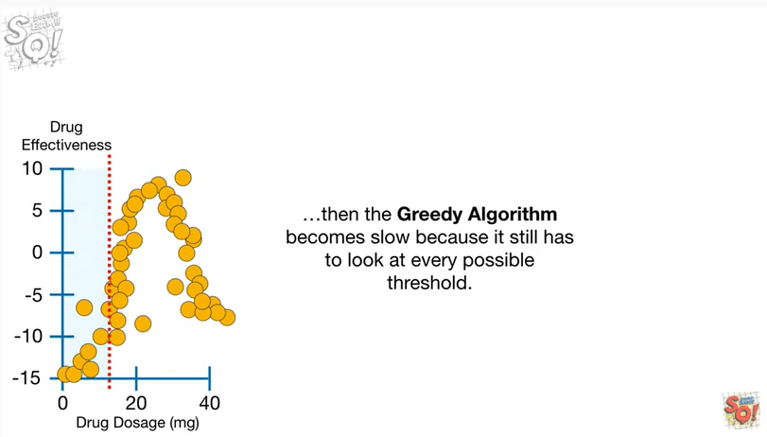

then the greedy algorithm becomes slow because it still has to look at every possible threshold.

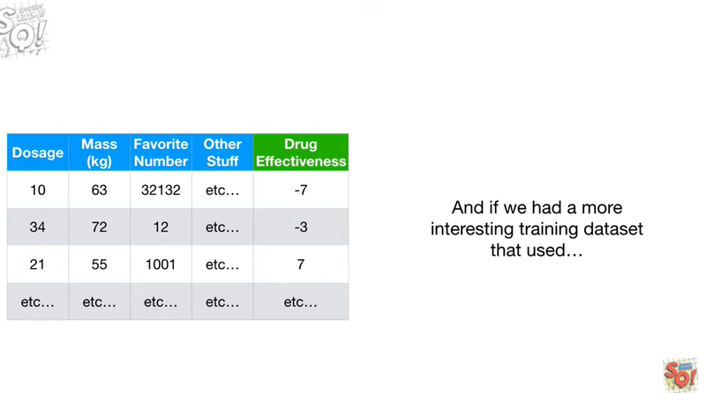

And if we had a more interesting training data set that used

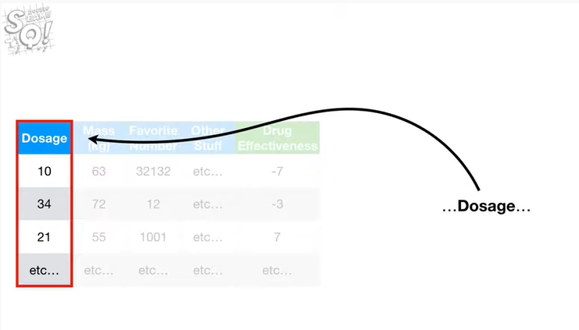

dosage

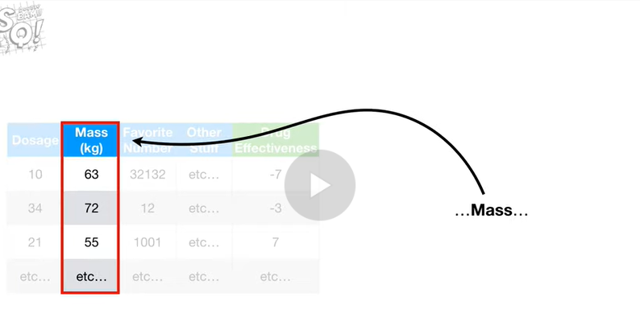

mass

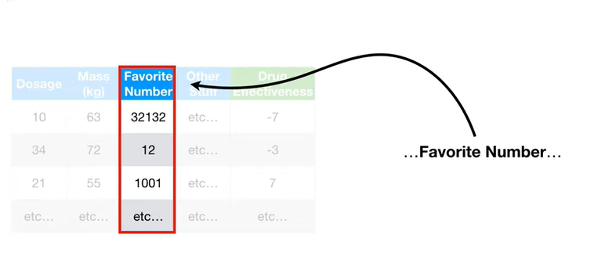

favorite number

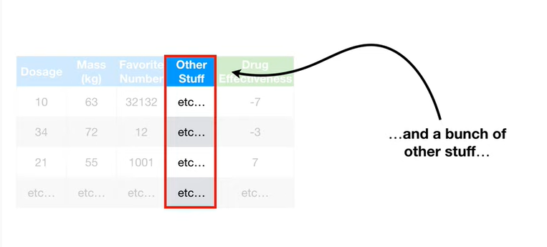

and a bunch of other stuff

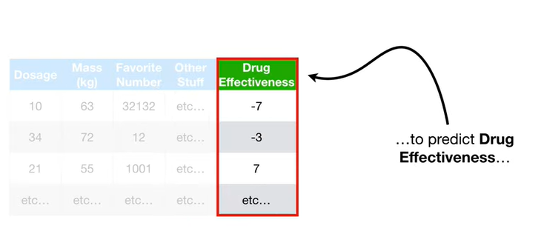

to predict drug effectiveness.

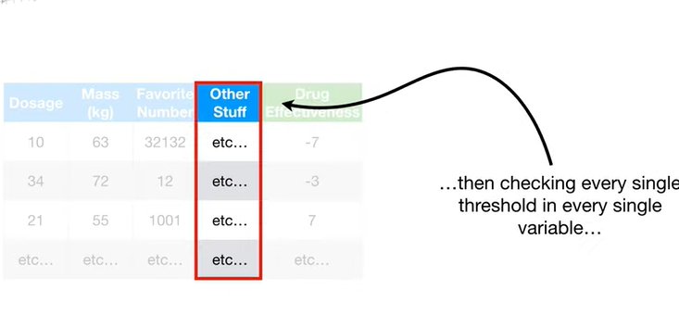

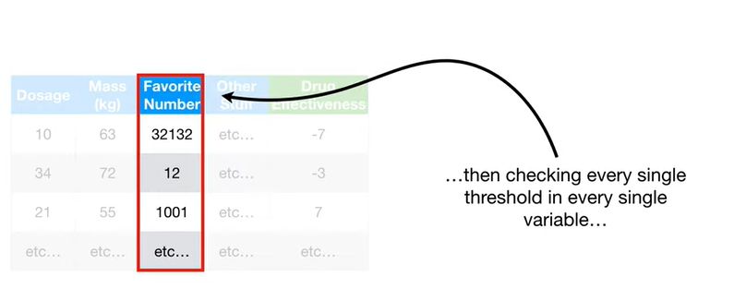

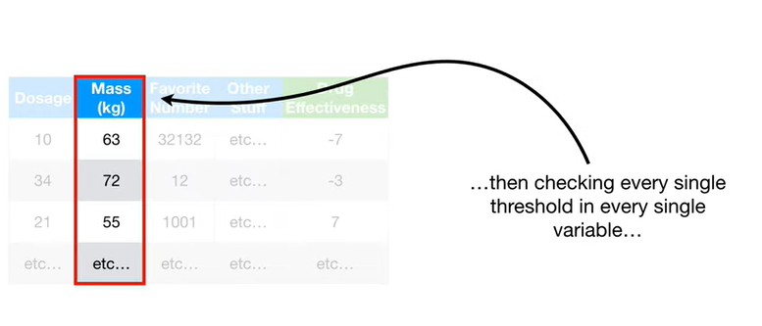

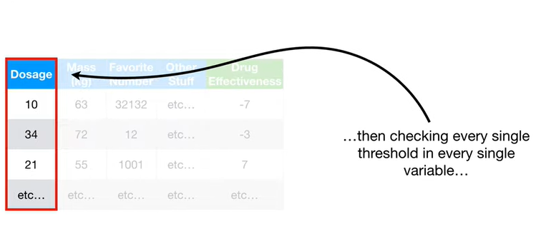

Then checking every single threshold in every single variable

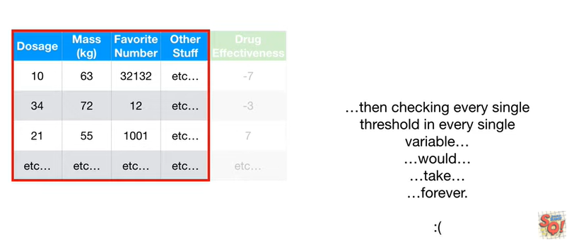

would take forever.

Wah, wah !!!

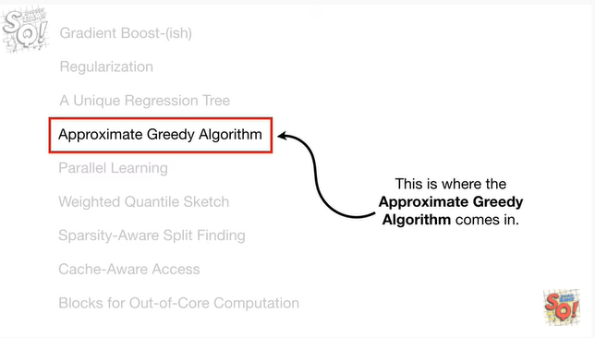

This is where the approximate greedy algorithm comes in.

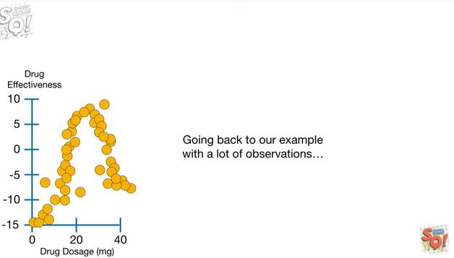

Going back to our example with a lot of observations

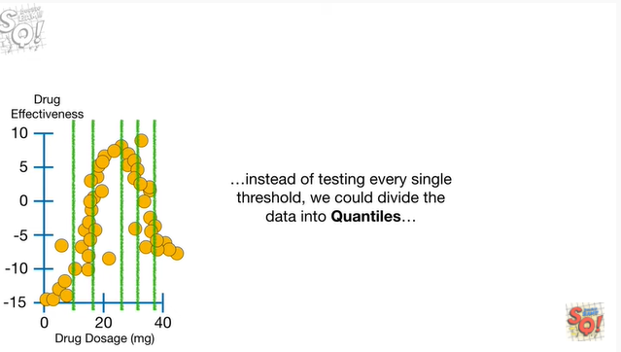

instead of testing every single threshold we could divide the data into quantiles

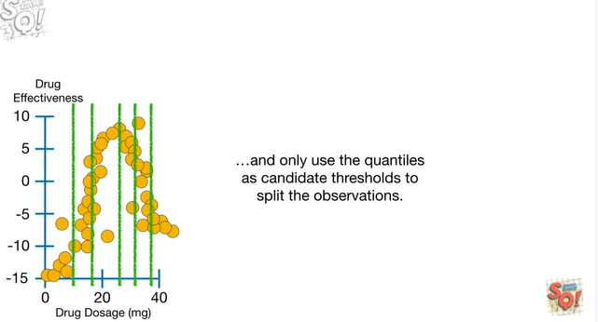

and only use the quantiles as candidate thresholds to split the observations.

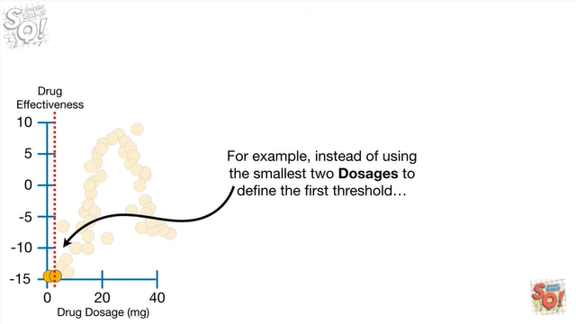

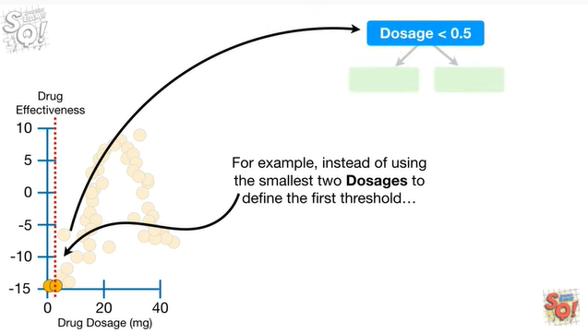

For example, instead of using the smallest two dosages to define the first threshold

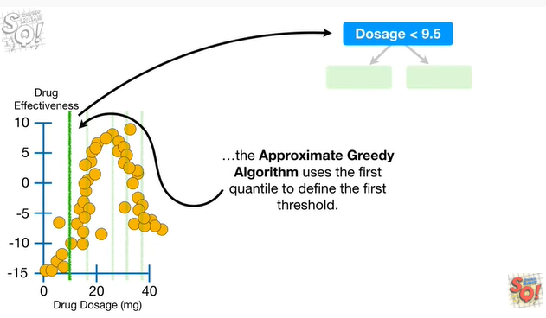

the approximate greedy algorithm uses the first quantile to define the first threshold.

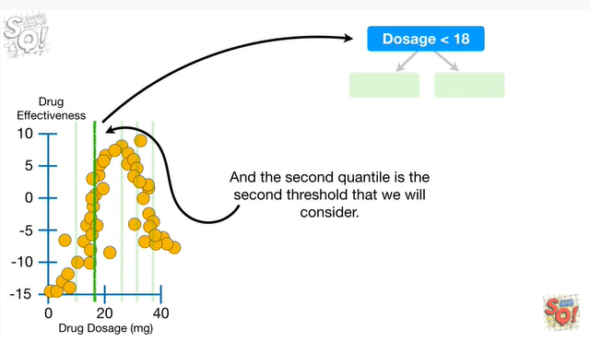

And the second quantile is the second threshold that we will consider

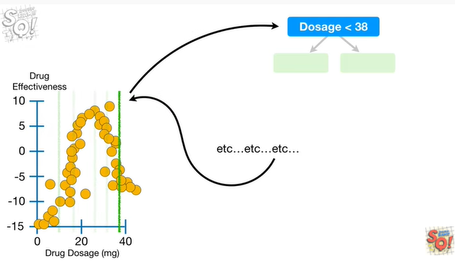

etcetera etc etc.

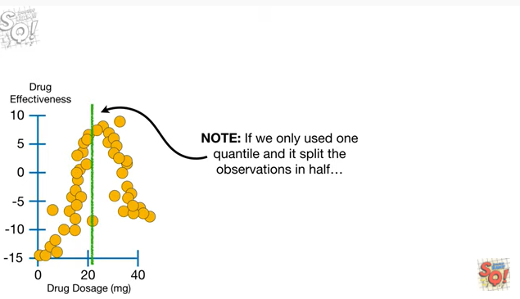

Note : if we only used one quantile and split the observations in half

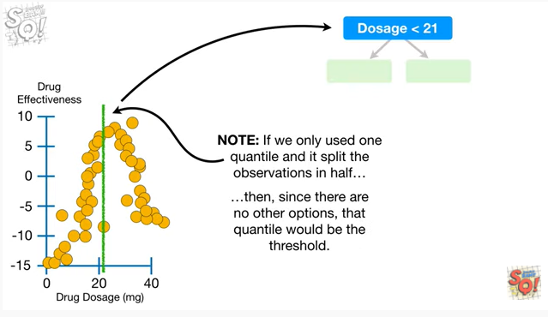

then since there are no other options that quantile would be the threshold.

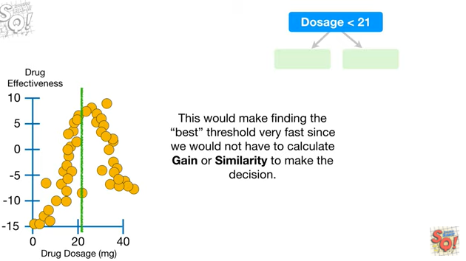

This would make finding the best threshold very fast since we would not have to calculate gain or similarity to make the decision.

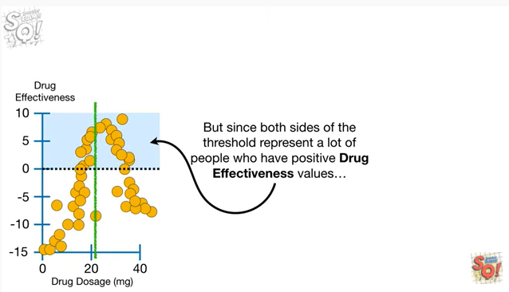

But since both sides of the threshold represent a lot of people who have positive drug effectiveness values

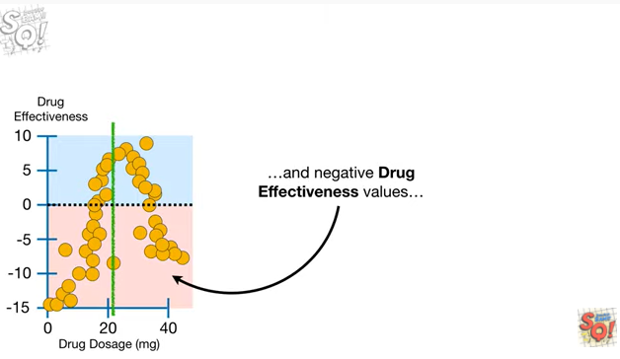

and a negative drug effectiveness values

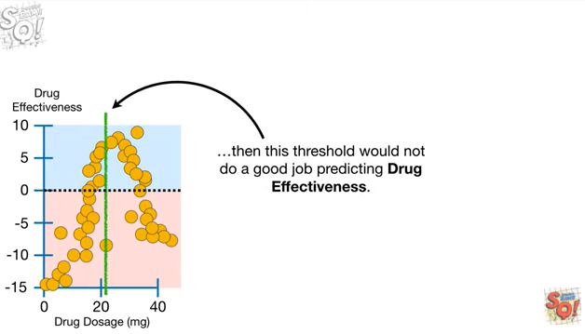

then this threshold would not do a good job predicting drug effectiveness.

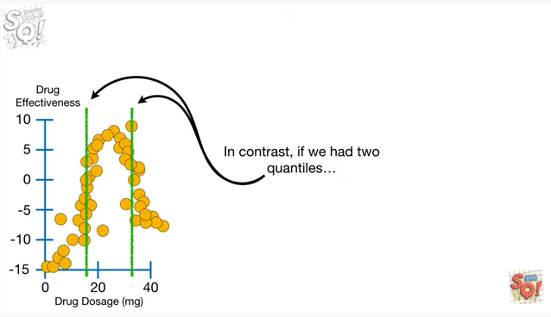

In contrast, if we had to quantiles

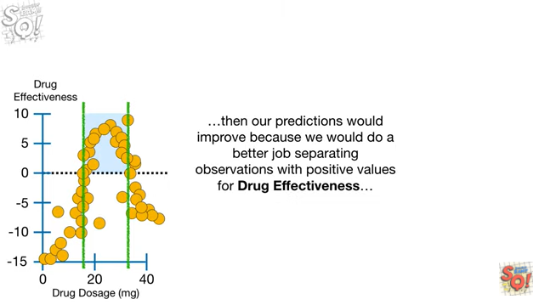

then our predictions would improve because we would do a better job separating observations with positive values for drug effectiveness

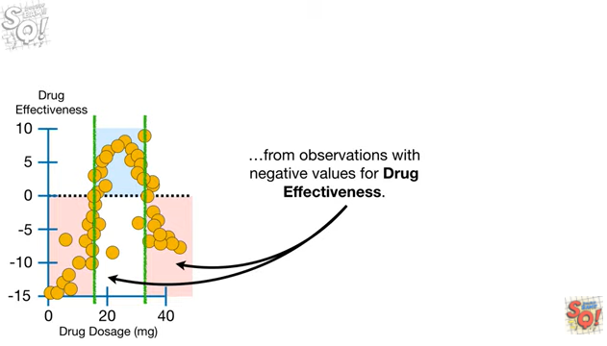

from observations with negative values for drug effectiveness.

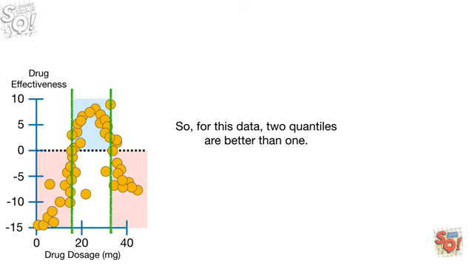

So, for this data to quantiles are better than one.

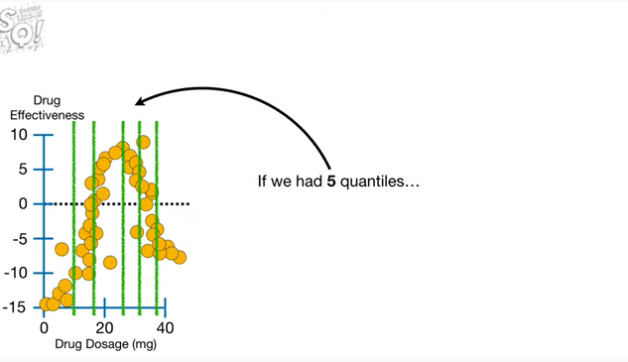

If we had five quantiles

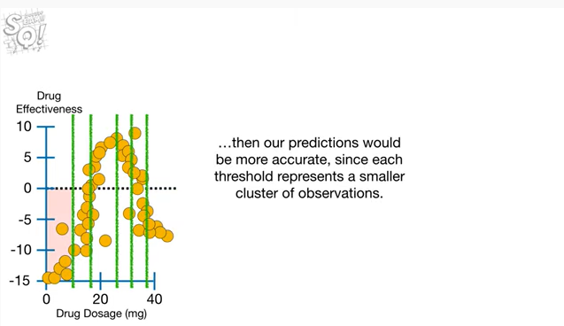

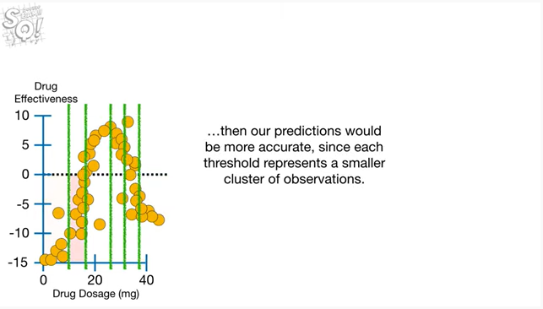

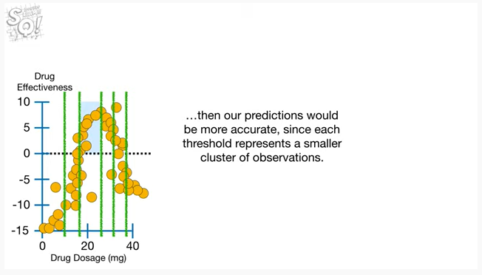

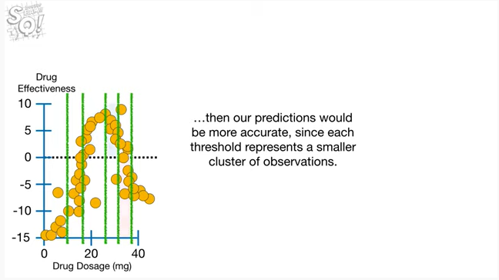

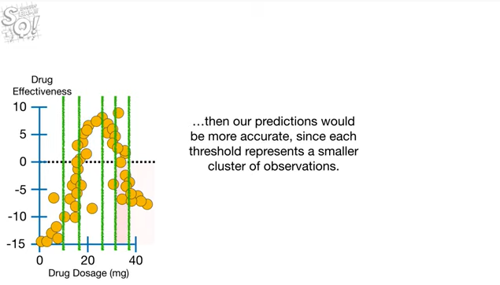

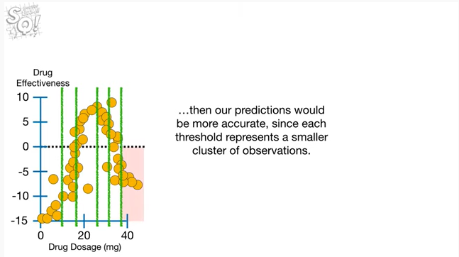

then our predictions would be more accurate since each threshold represents a smaller cluster of observations.

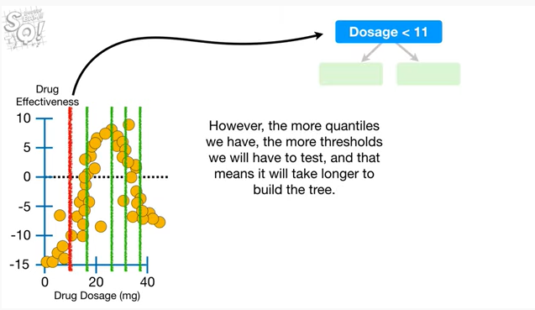

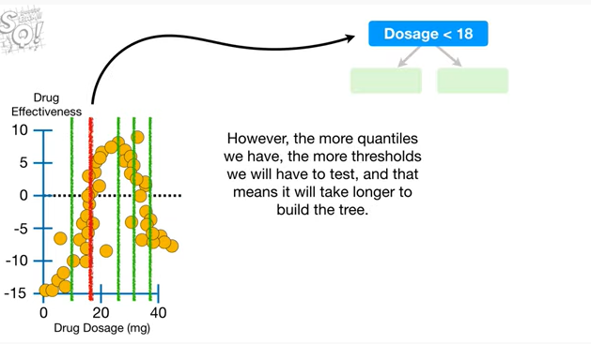

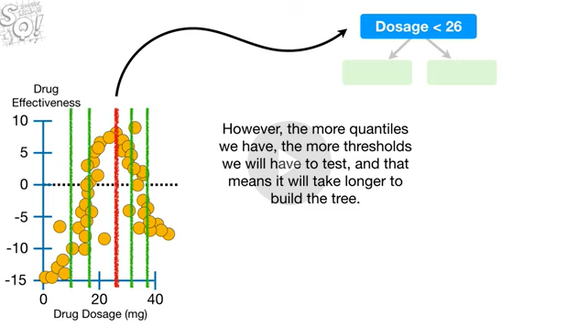

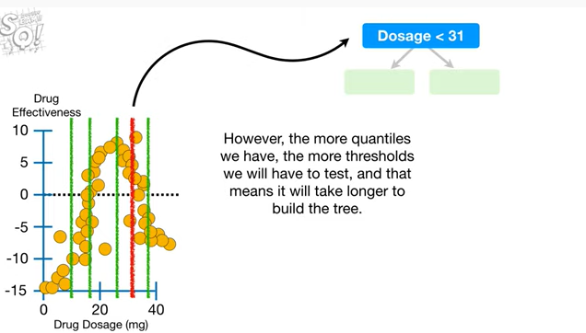

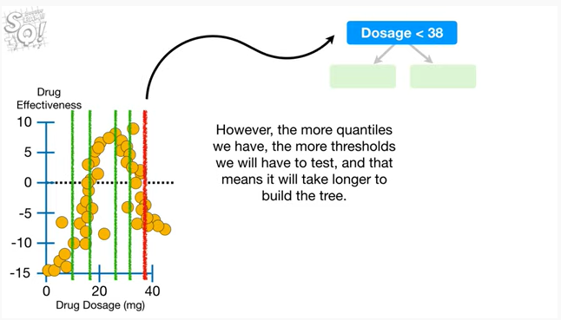

However, the more quantiles we have the more thresholds we will have to test and that means it will take longer to build the tree.

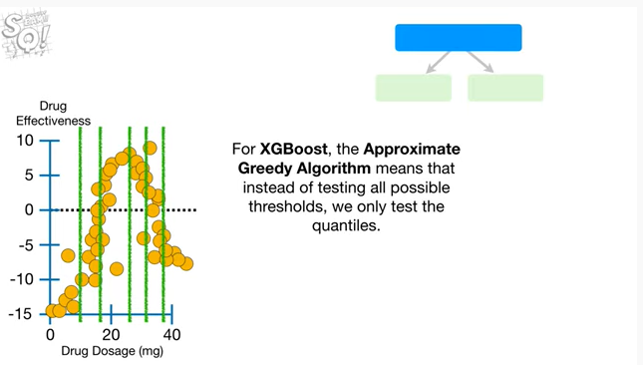

For XGBoost, the approximate greedy algorithm means that instead of testing all possible thresholds, we only test the quantiles.

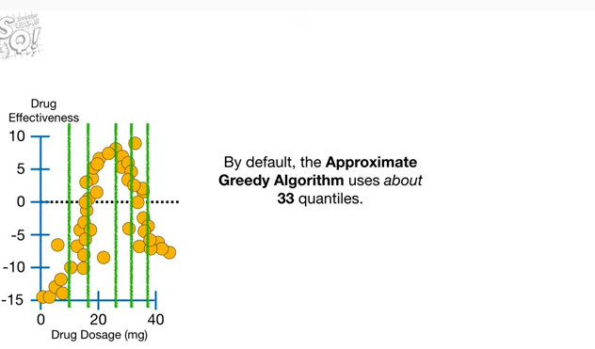

And by default the approximate greedy algorithm uses about 33 quantiles.

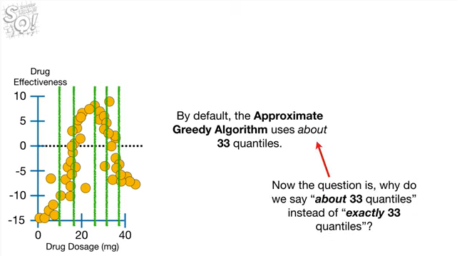

Now the question is why do we say about 33 quantiles instead of exactly 33 quantiles ?

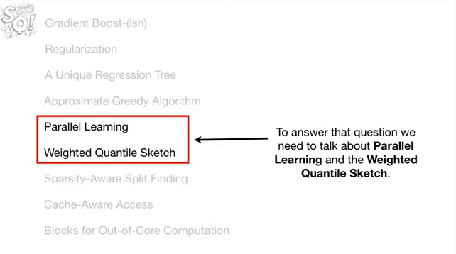

To answer this question we need to talk about parallel learning and the weighted quantile sketch.

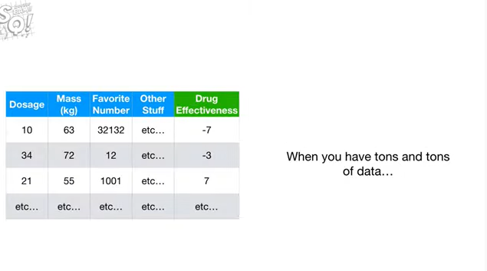

When you have tons and tons of data

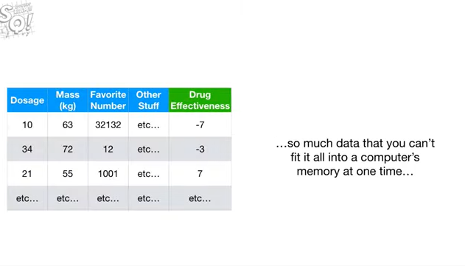

so much data that you can't fit it all into a computer's memory at one time

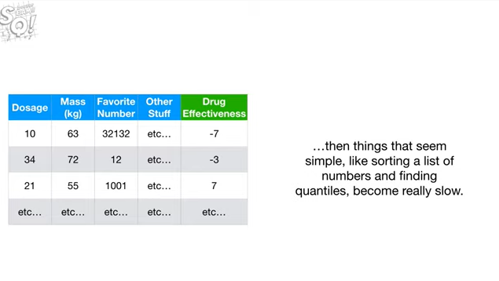

then things that seem simple like sorting a list of numbers and finding quantiles, become really slow.

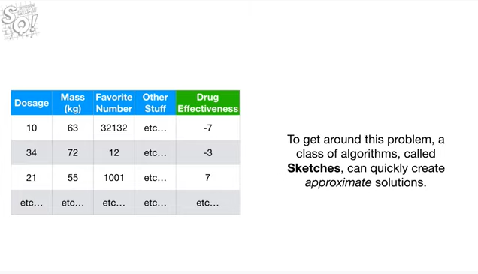

To get around this problem, a class of algorithms, called sketches, can quickly create approximate solutions.

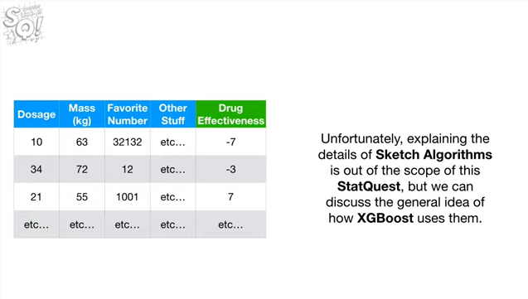

Unfortunately, explaining the details of sketch algorithms is out of the scope of this stat quest, but we can discuss the general idea of how XGBoost uses them.

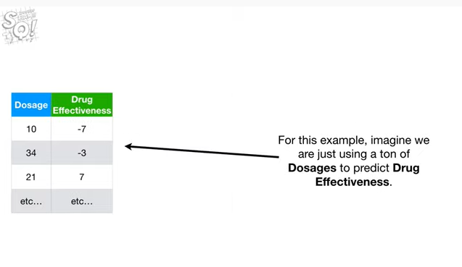

For this example, imagine we are just using a ton of dosages to predict drug effectiveness.

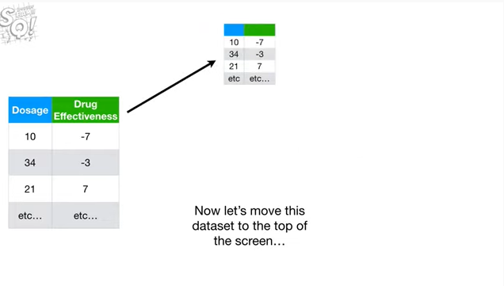

Now let's move this data set to the top of the screen

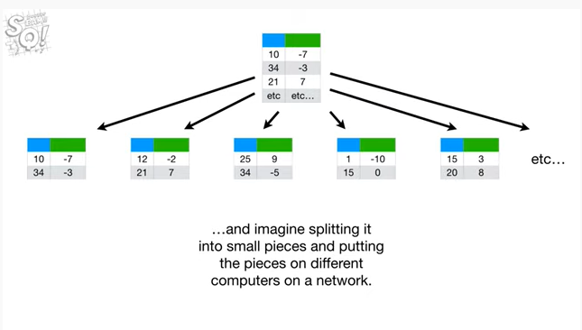

and imagine splitting it into small pieces and putting the pieces on different computers on a network.

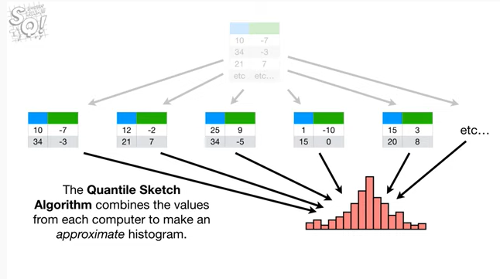

The quantile sketch algorithm combines the values from each computer to make an approximate histogram.

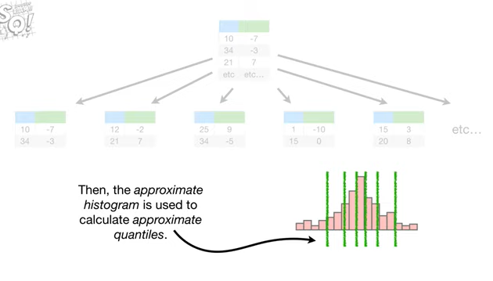

Then the approximate histogram is used to calculate approximate quantiles.

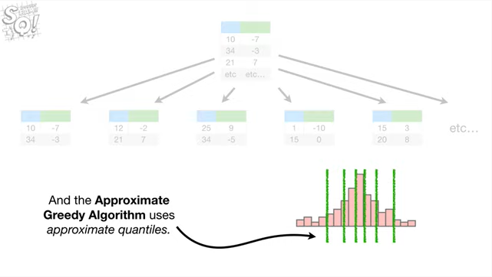

And the approximate greedy algorithm uses approximate quantiles.

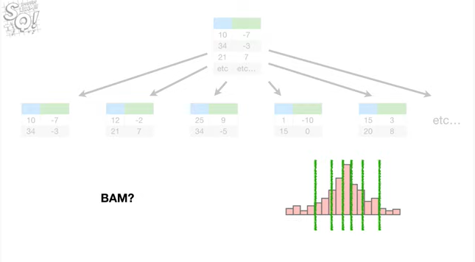

BAM ?

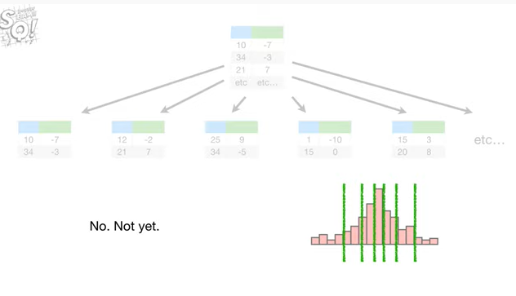

No.

Not yet.

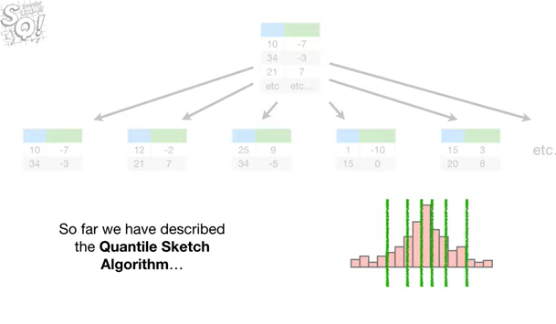

So far we have described the quantile sketch algorithm

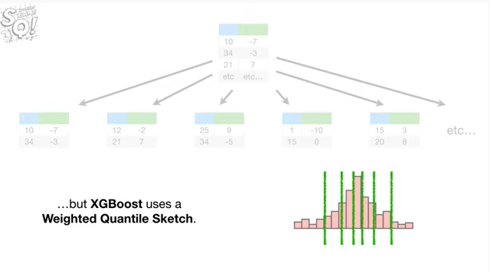

but XGBoost uses a weighted quantile sketch.

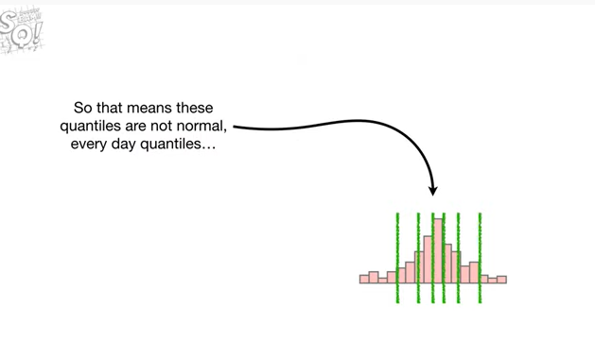

So that means that these quantiles are not normal, everyday quantiles

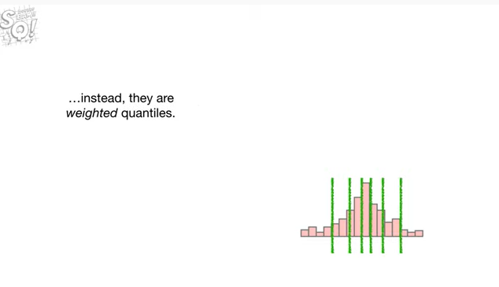

instead they are weighted quantiles.

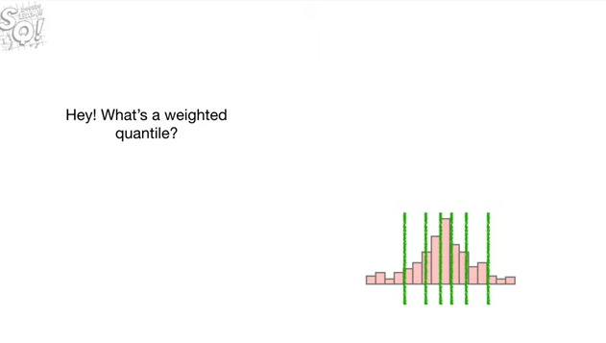

Hey !

What's a weighted quantile ?

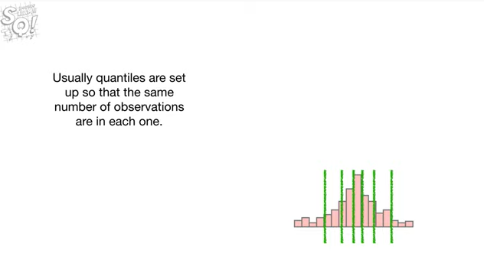

Usually quantiles are set up so that the same number of observations are in each one.

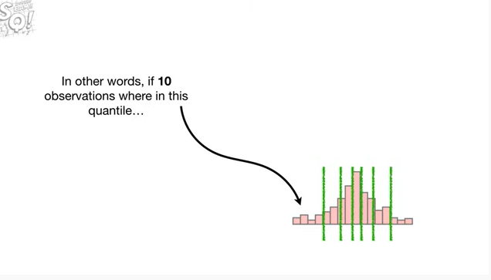

In other words, if ten observations were in this quantile

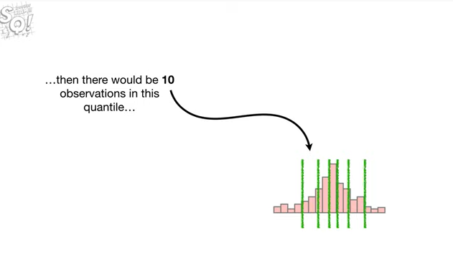

then there would be ten observations in this quantile

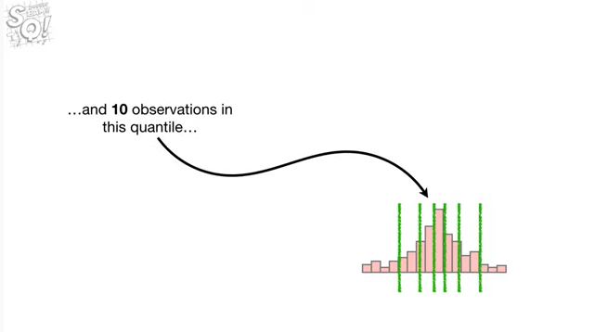

and ten observations in this quantile

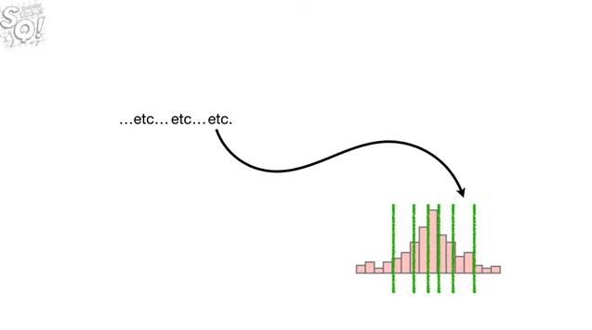

etc etc.

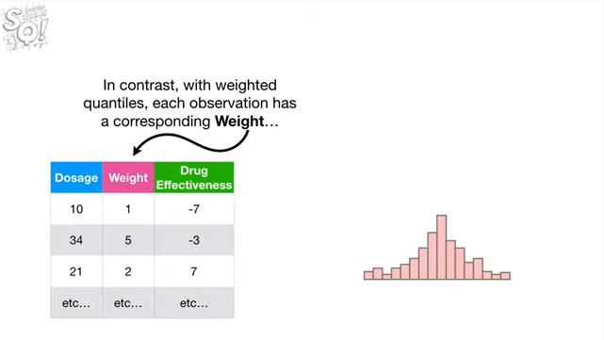

In contrast with weighted quantiles each observation has a corresponding weight

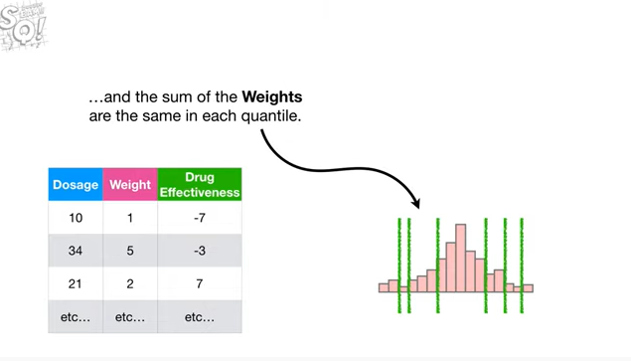

and the sum of the weights are the same in each quantile.

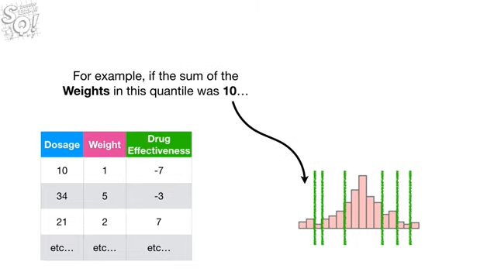

For example, if the sum of the weights in this quantile was 10

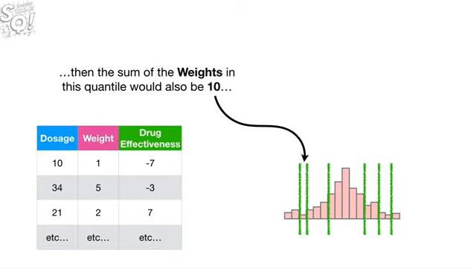

then the sum of the weights in this quantile would also be 10

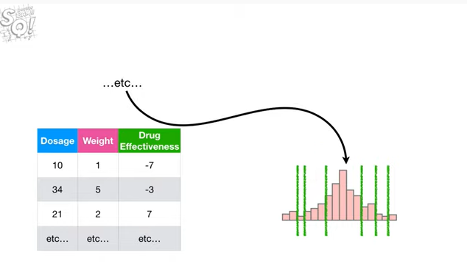

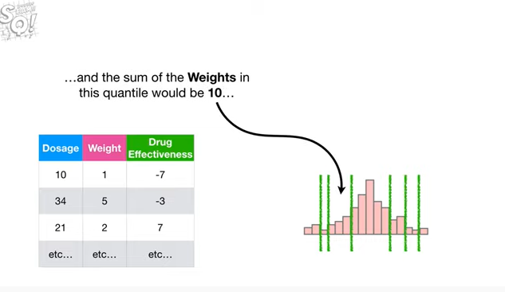

and the sum of the weights in this quantile would be 10

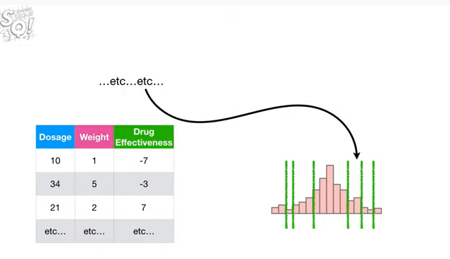

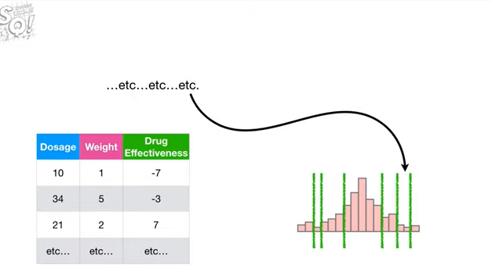

etc etc etc.

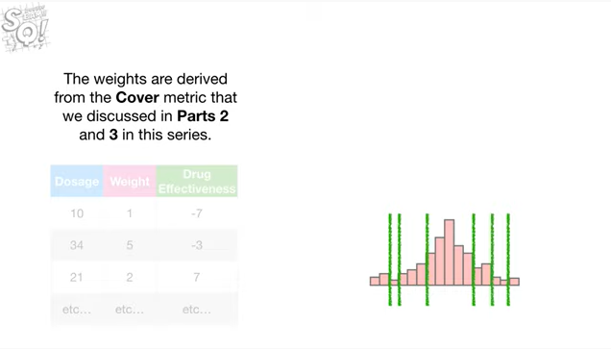

The weights are derived from the cover metric that we discussed in parts two and three in this series.

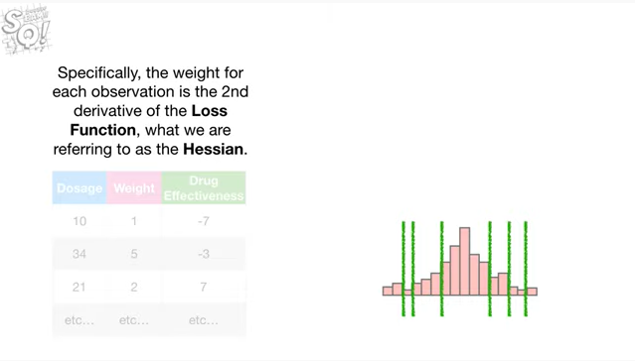

Specifically, the weight for each observation is the second derivative of the loss function what we are referring to as the hessian.

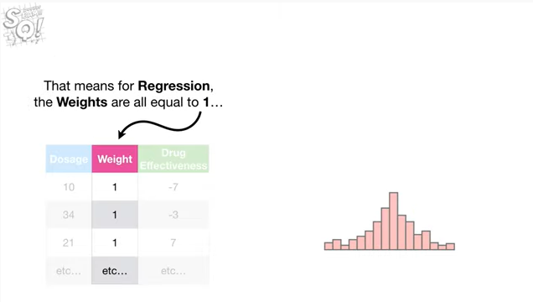

That means per regression the weights are all equal to one

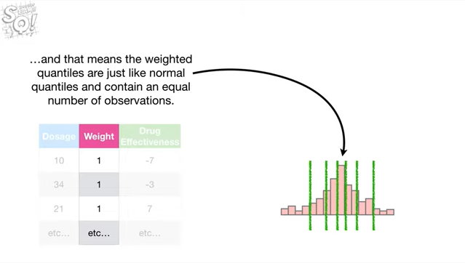

and that means the weighted quantile czar just like the normal quantile and contain an equal number of observations.

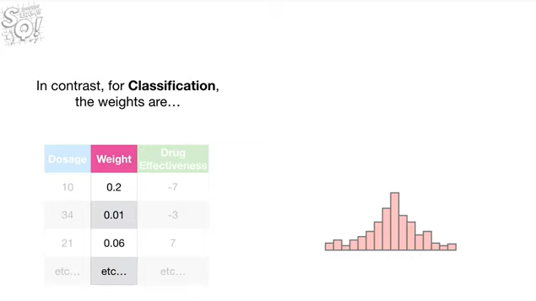

In contrast, for classification the weights are

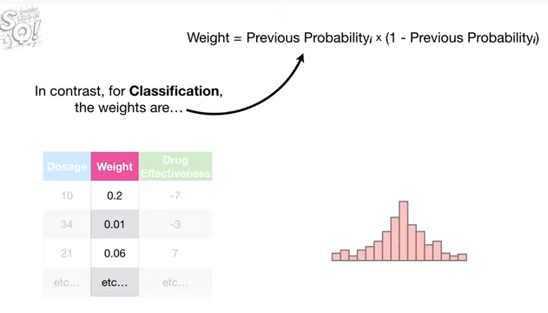

the previous probability times one minus the previous probability.

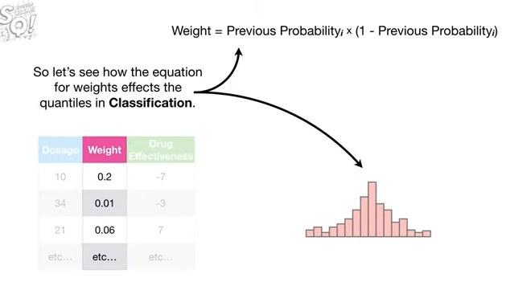

So let's see how the equation for weights affects the quantiles in classification.

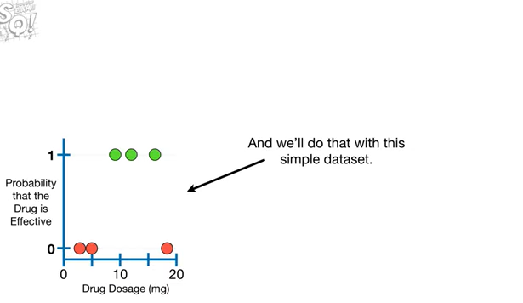

And we'll do that with this simple data set.

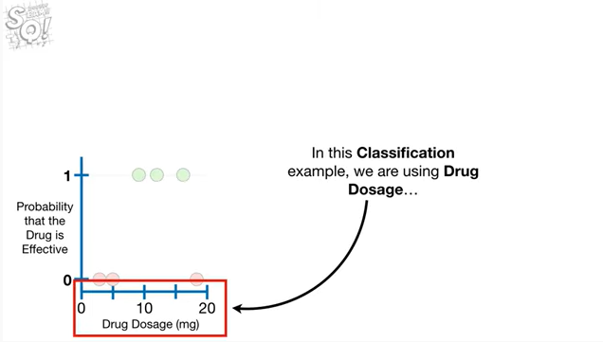

In this classification example, we are using drug dosage

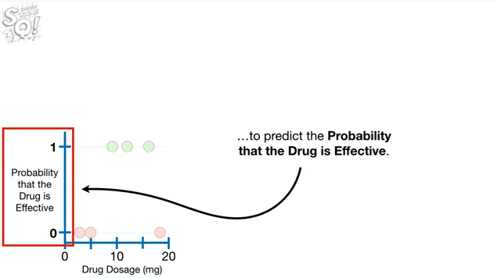

to predict the probability that the drug is effective.

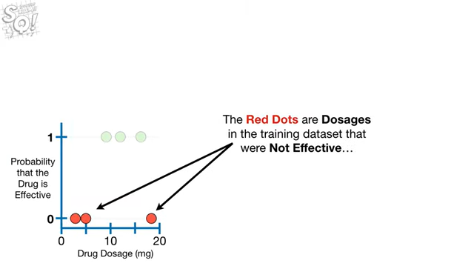

The red dots are dosages in the training data set that were not effective

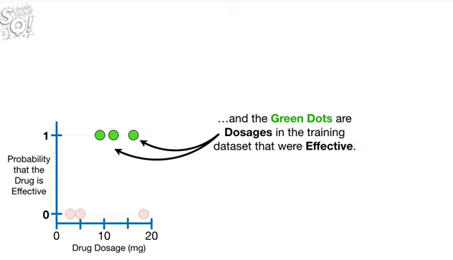

and the green dots are dosages in the training data set that were effective.

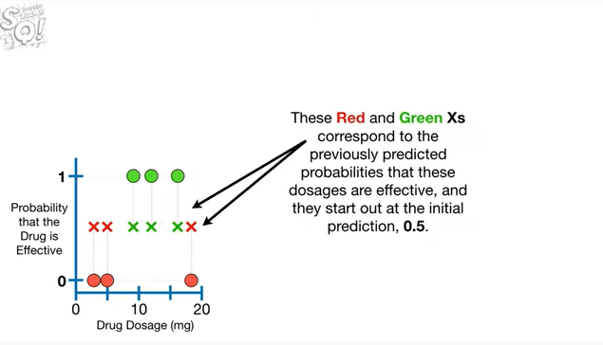

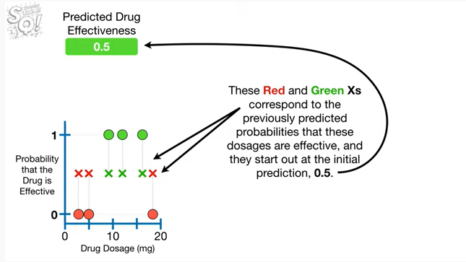

These red and green X's correspond to the previously predicted probabilities that these dosages are effective and they start out at the initial prediction, 0.5.

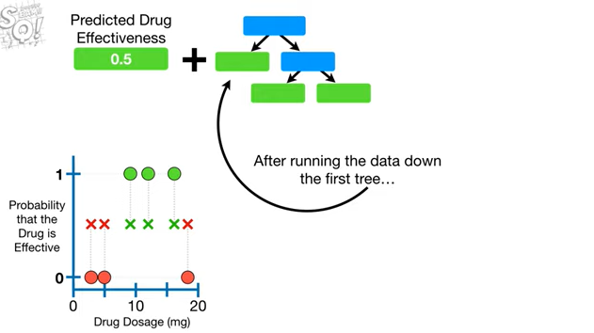

After running the data down the first tree

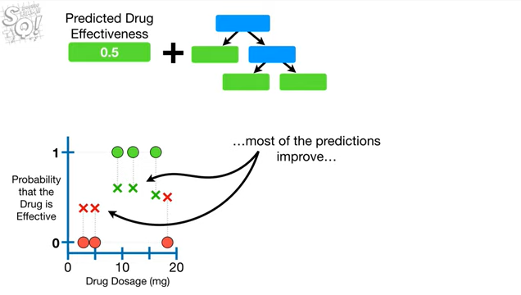

most of the predictions improve

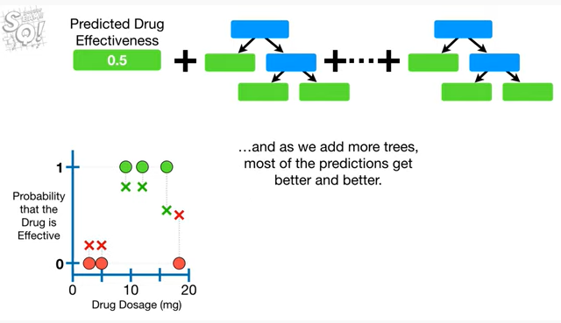

and as we add more trees, most of the predictions get better and better.

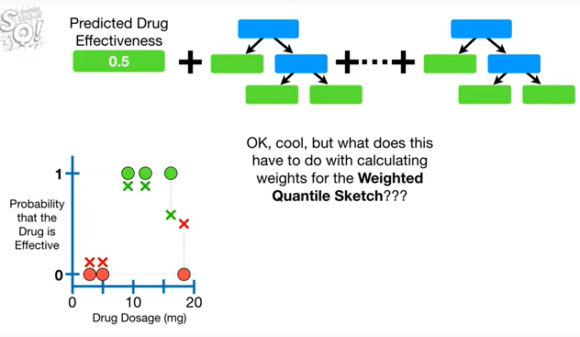

Okay, cool, but what does this have to do with calculating the weights for the weighted quantile sketch ???

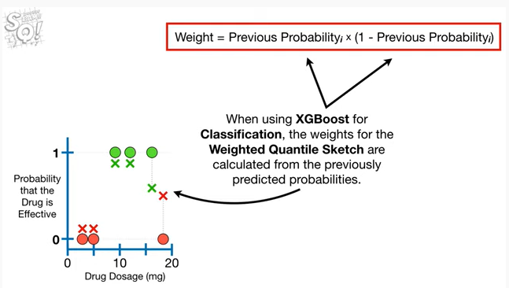

When using XGBoost for classification, the weights for the weighted quantile sketch are calculated from the previously predicted probabilities.

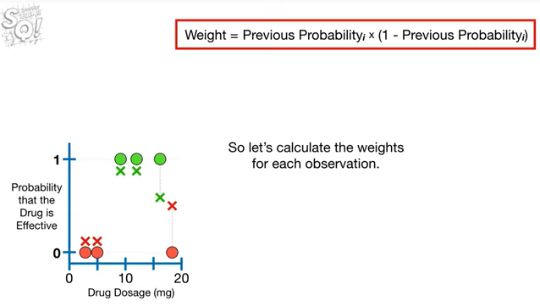

So let's calculate the weights for each observation.

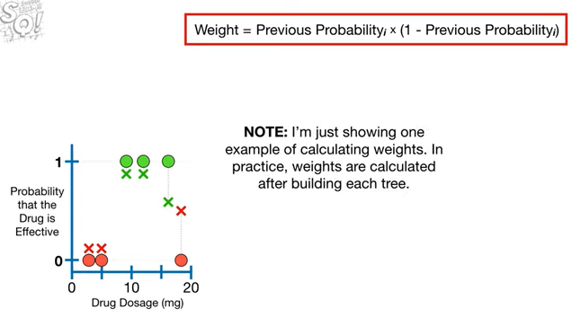

Note : I'm just showing one example of calculating weights.

In practice, weights are calculated after building each tree.

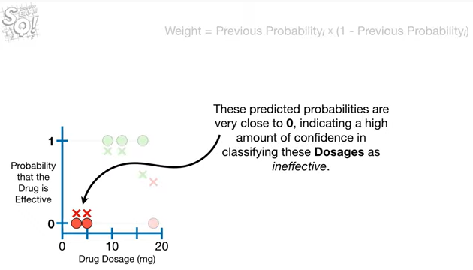

These predicted probabilities are very close to zero, indicating a high amount of confidence in classifying these dosages as ineffective.

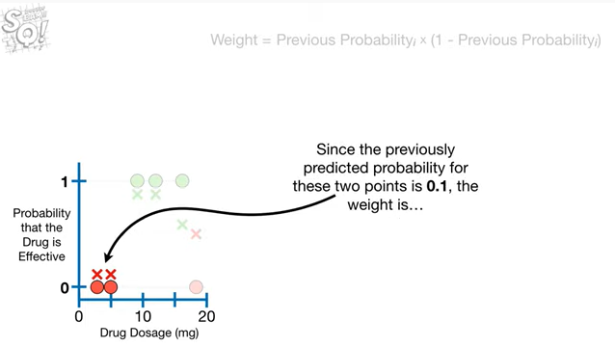

Since the previously predicted probability for these two points is 0.1, the weight is

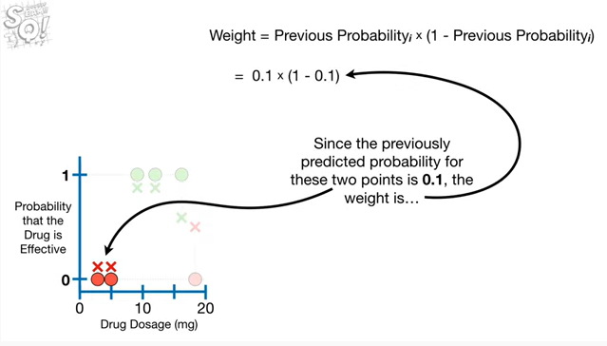

0.1 times 1 minus 0.1

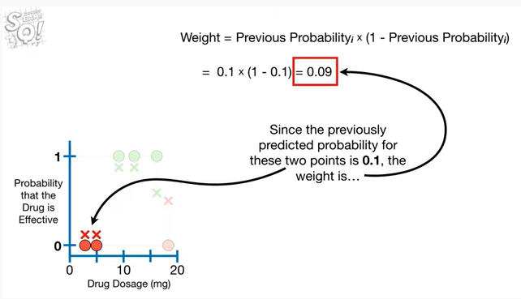

which equals 0.09.

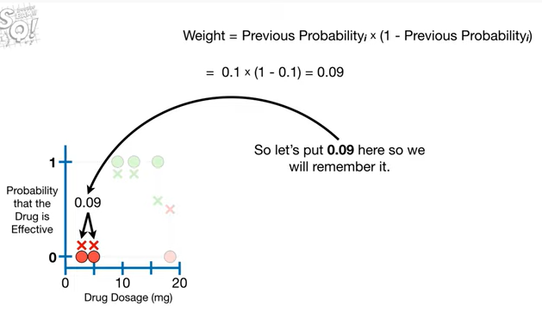

So let's put 0.09 here so we will remember it.

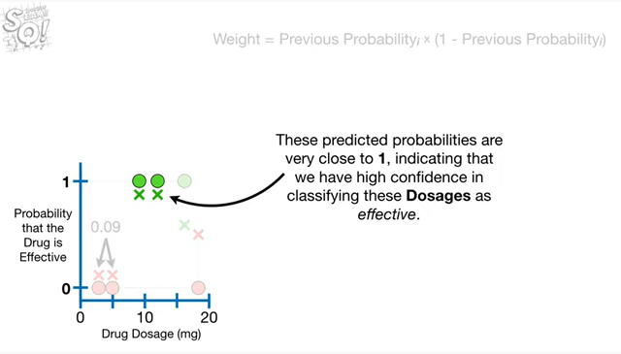

These predicted probabilities are very close to 1, indicating we have high confidence in classifying these dosages as effective.

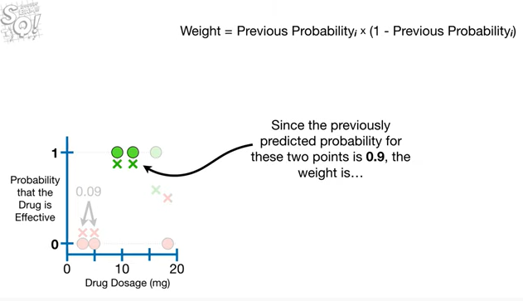

Since the previously predicted probability for these two points is 0.9 the weight is

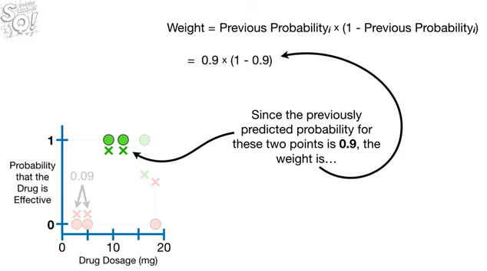

0.9 times 1 minus 0.9

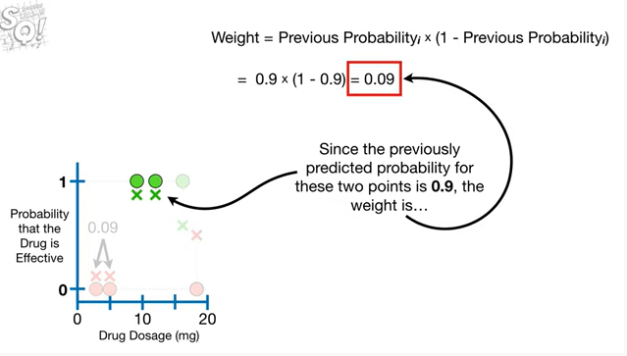

which equals 0.09.

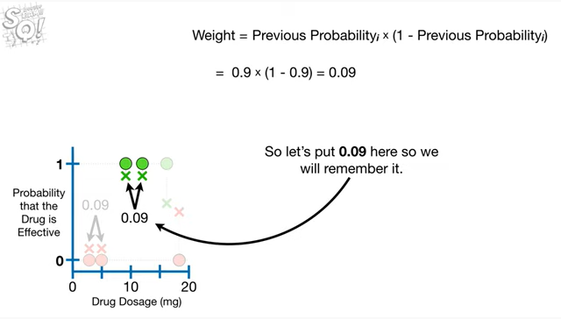

So let's put 0.09 here so we will remember it.

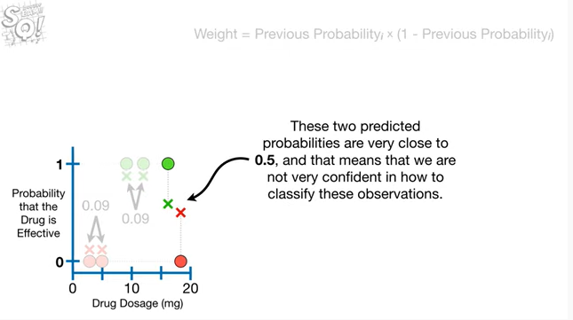

These two predicted probabilities are very close to 0.5, and that means that we are not very confident in how to classify these observations.

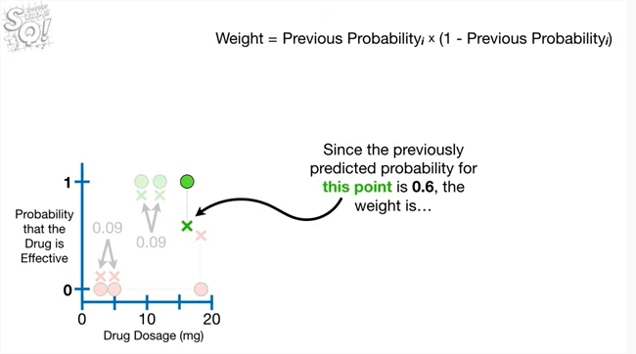

Since the previously predicted probability for this point is 0.6, the weight is

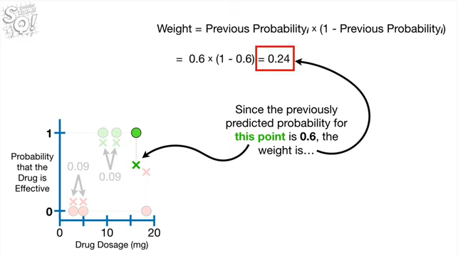

0.24.

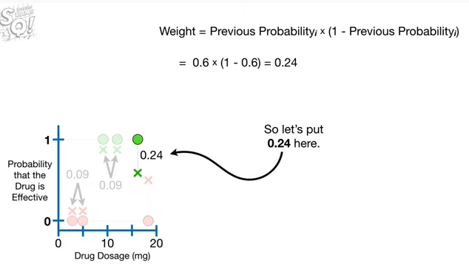

So let's put 0.2 for here.

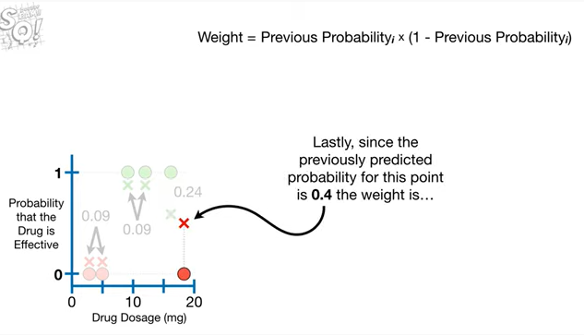

Lastly, since the previously predicted probability for this point is 0.4 the weight is

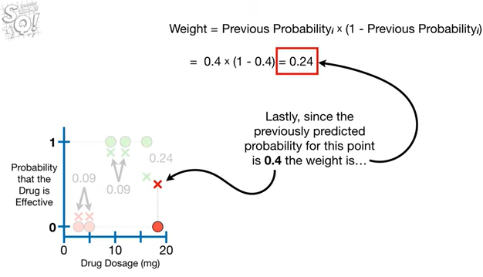

0.24.

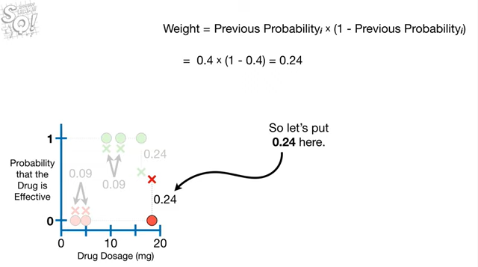

So let's put 0.24 here.

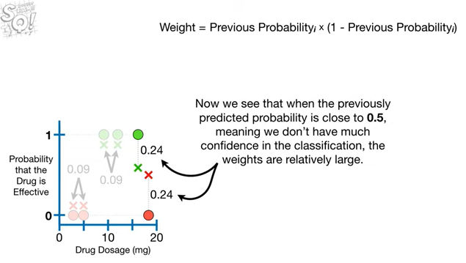

Now we see that when the previously predicted probability is close to 0.5, meaning we don't have much confidence in the classification the weights are relatively large.

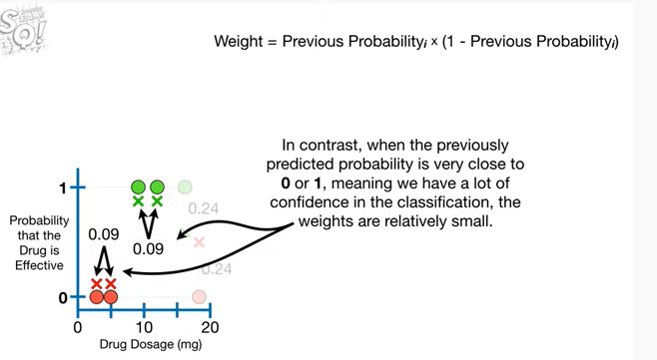

In contrast, when the previously predicted probability is very close to zero or one, meaning we have a lot of confidence in the classification the weights are relatively small.

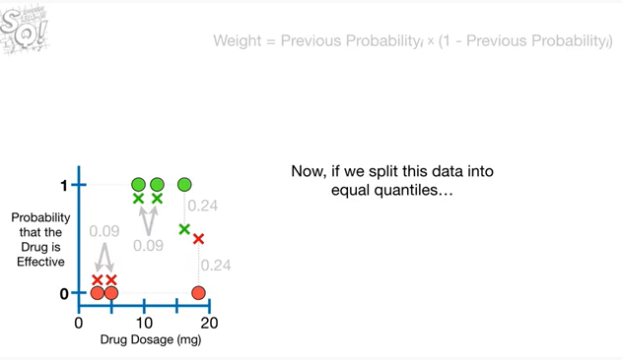

Now if we split this data into equal quantiles

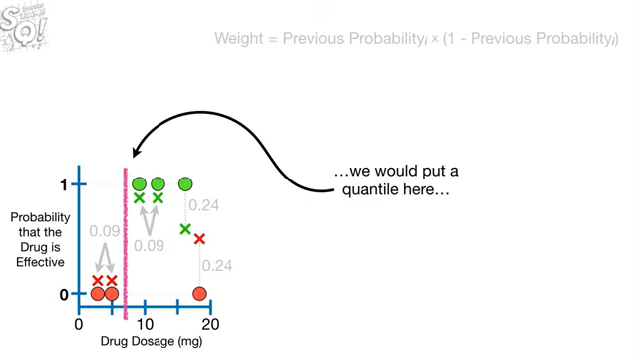

we would put a quantile here

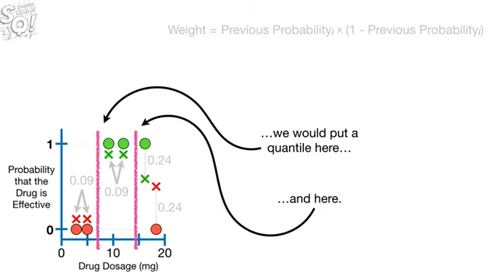

and here.

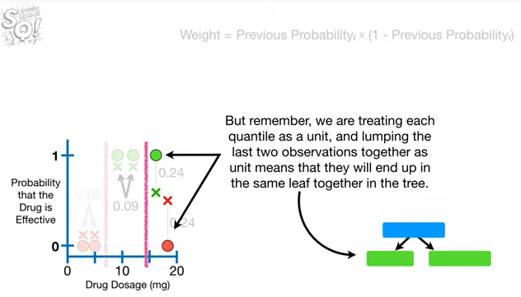

But remember we are treating each quantile as a unit and lumping the last two observations together as a unit means they will end up in the same leaf together in the tree.

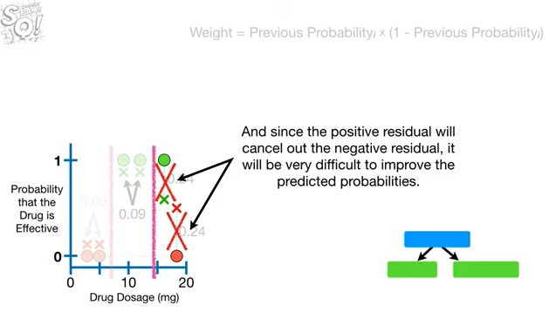

And since the positive residual will cancel out the negative residual, it will be very difficult to improve the predicted probabilities.

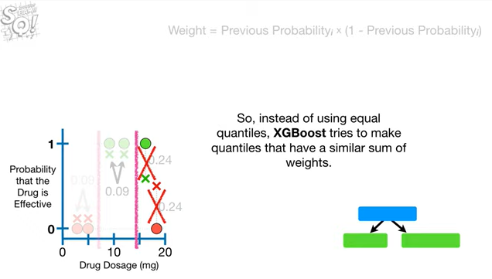

So instead of using equal quantiles, XGBoost tries to make quantiles that have a similar sum of weights.

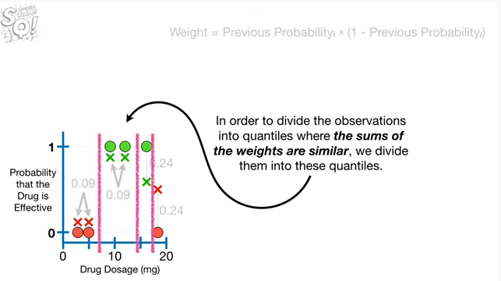

In order to divide the observations into quantiles where the some of the weights are similar, we divide them into these quantiles.

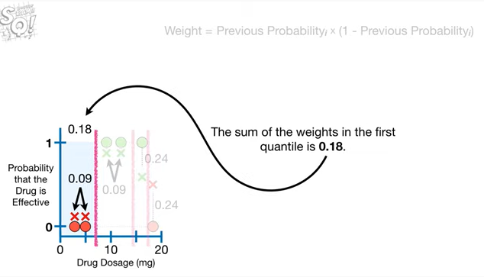

The sum of the weights in the first quantile is 0.18.

Some of the weights in the second quantile is 0.18.

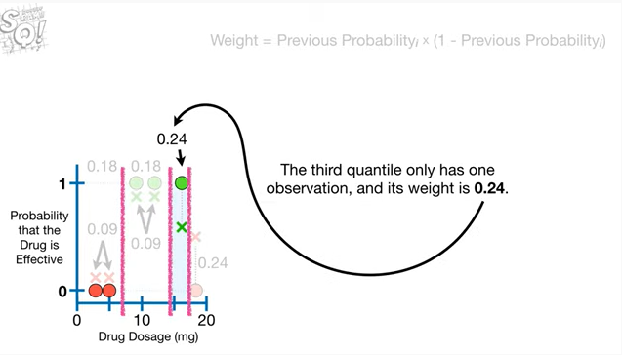

The third quantile only has one observation in its weight is 0.24.

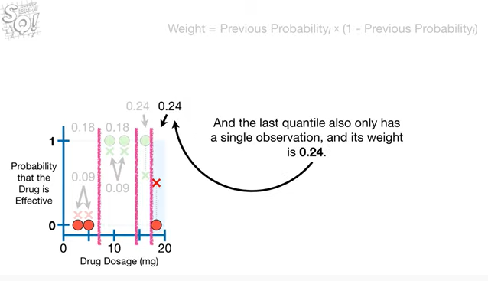

And the last quantile only has a single observation and its weight is 0.24.

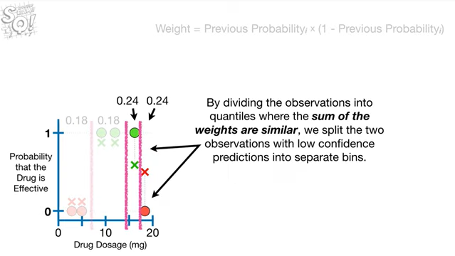

By dividing the observations into quantiles where the sum of the weights are similar, we split the two observations with low confidence predictions in two separate bins.

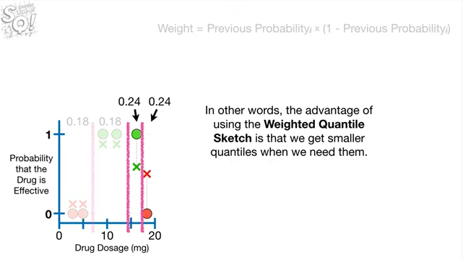

In other words, the advantage of using the weighted quantile sketch is that we get smaller quantiles when we need them.

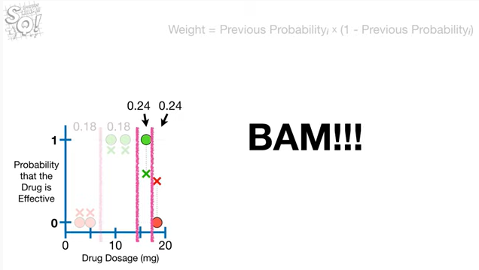

BAM !!!

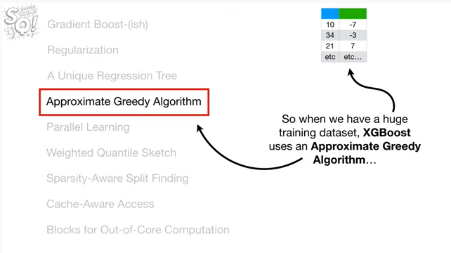

So when we have a huge training data set XGBoosts uses an approximate greedy algorithm

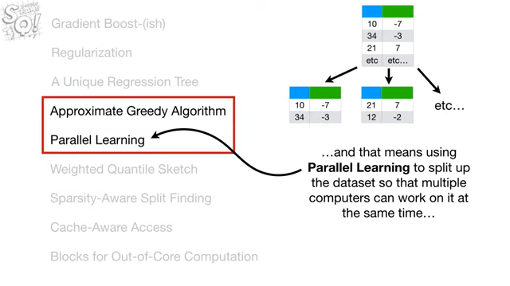

and that means using parallel learning to split up the data sets so that multiple computers can work on it at the same time

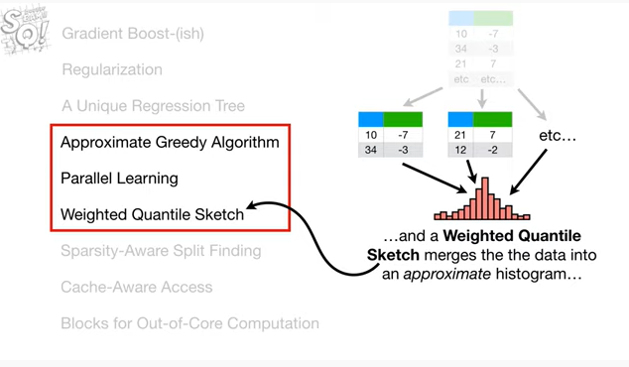

and a weighted quantile sketch merges the data into an approximate histogram

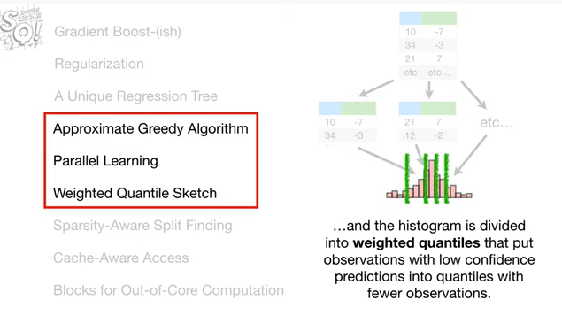

and the histogram is divided into weighted quantile that put observations with low confidence predictions into quantiles with fewer observations.

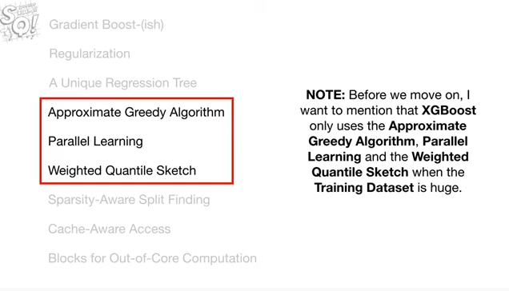

Note : before we move on, I want to mention that XGBoost only uses the approximate greedy algorithm, parallel learning and the weighted quantile sketch when the training data set is huge.

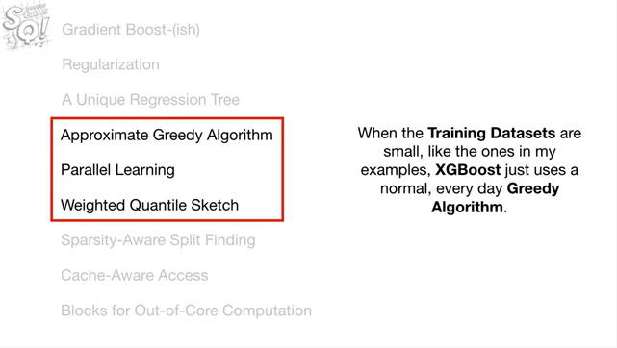

when the training data sets are small like the ones in my examples, XGBoost just uses a normal everyday greedy algorithm.

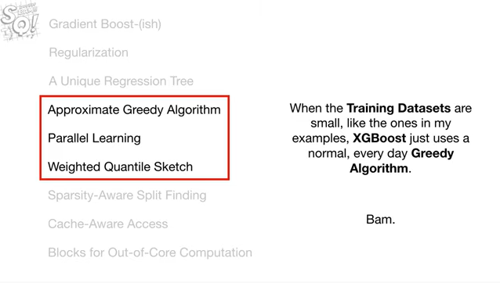

BAM .

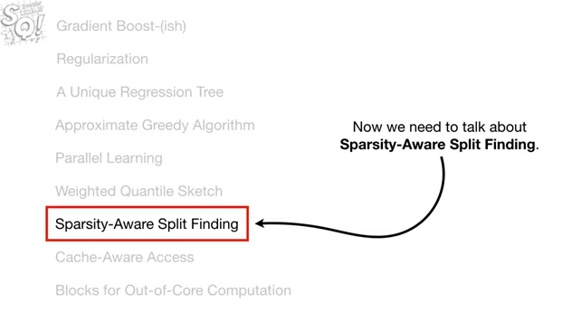

Now let's talk about sparsity aware split finding.

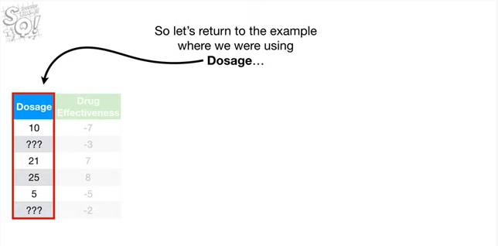

So let's return to the example where we were using dosage

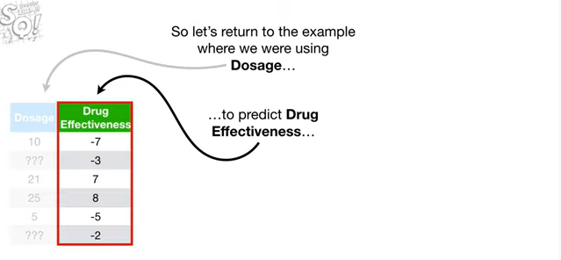

to predict drug effectiveness

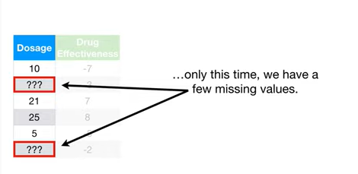

only this time, we have a few missing values.

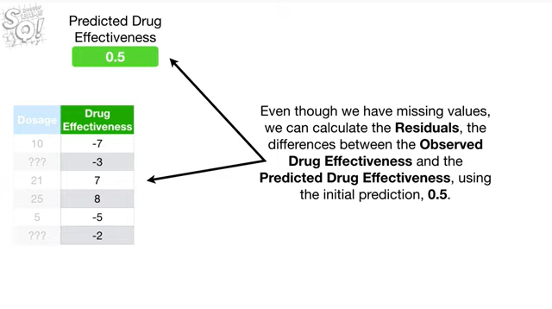

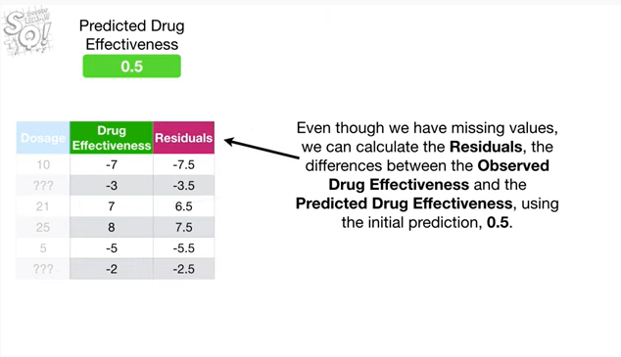

Even though we have missing values, we can calculate the residuals, the differences between the observed drug effectiveness and the predicted drug effectiveness using the initial prediction, 0.5.

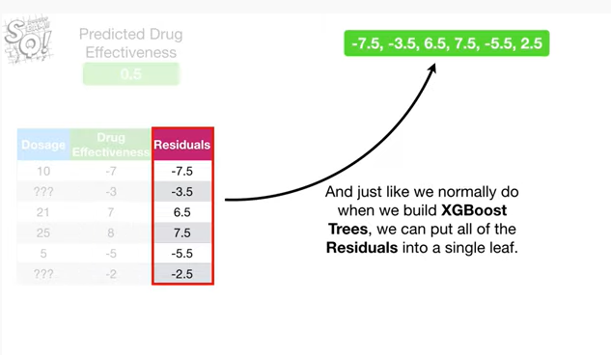

And just like we normally do when we build XGBoost trees we can put all of the residuals into a single leaf.

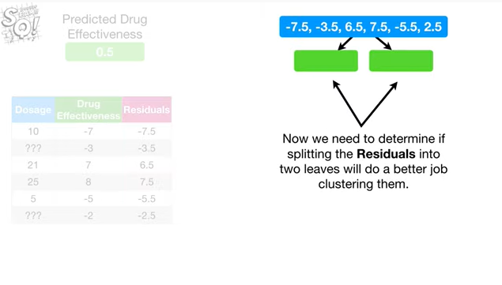

Now we need to determine if splitting the residuals into two leaves will do a better job clustering them.

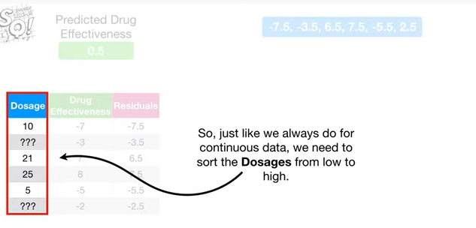

So, just like we always do for continuous data we need to sort the dosages from low to high.

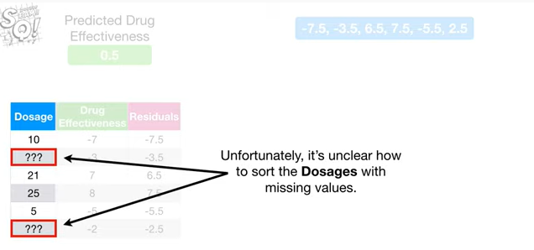

Unfortunately, it's unclear how to sort the dosages with missing values.

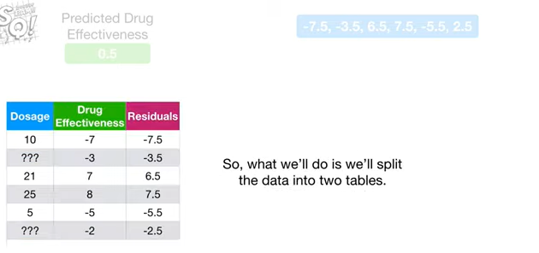

So what we'll do is we'll split the data into two tables.

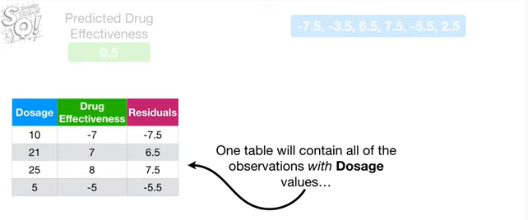

One table will contain all of the observations with dosage values

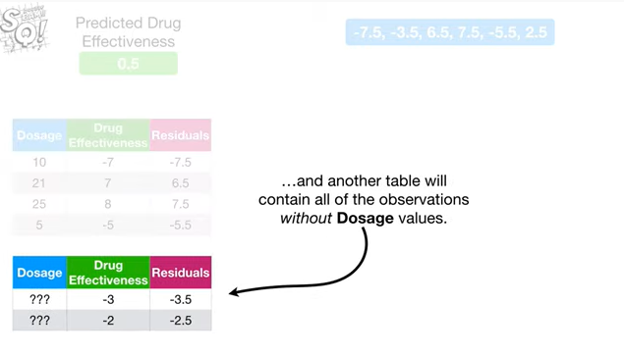

and another table will contain all of the observations without dosage values.

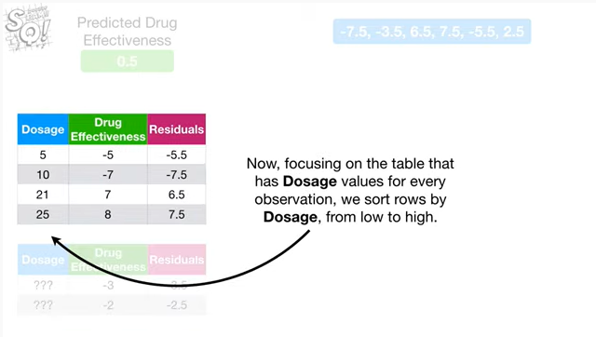

Now focusing on the table that has dosage values for every observation, we sort rose by dosage, from low to high.

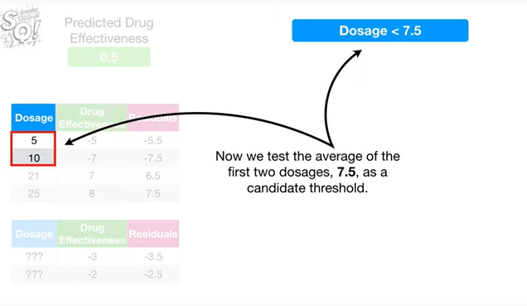

Now we test the average of the first two dosages, 7.5, as a candidate threshold.

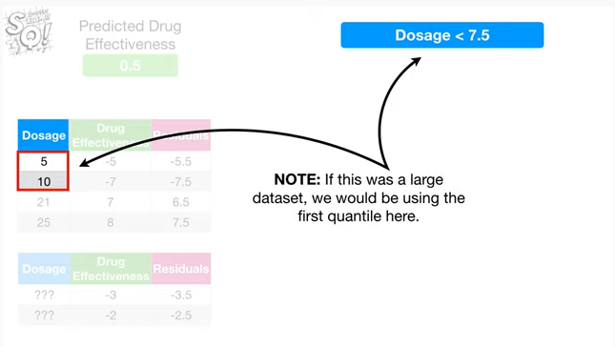

Note : if this was a large data set we would be using the first quantile here.

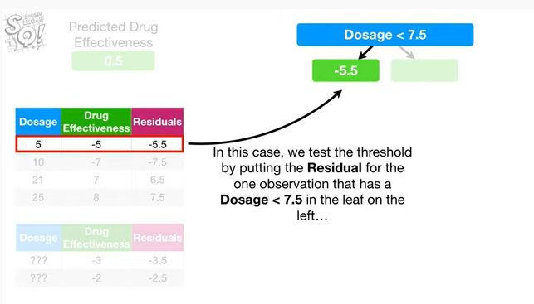

In this case, we test the threshold by putting the residual for the one observation that has a dosage less than seven point five in the leaf on the left

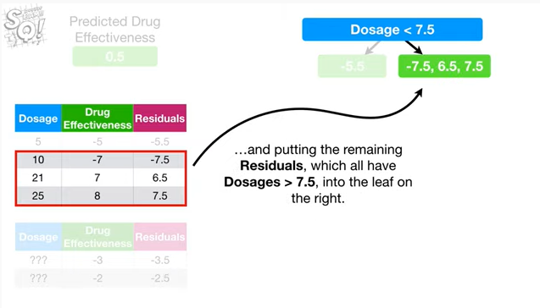

and putting the remaining residuals which all have dosages greater than seven point five, into the leaf on the right.

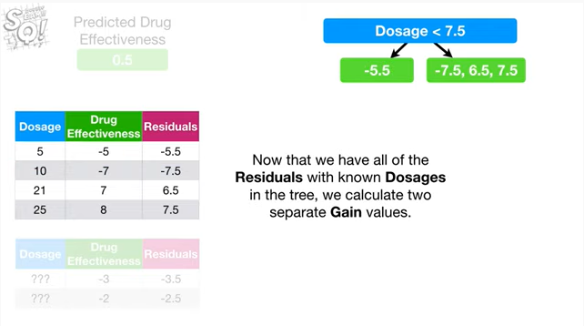

Now that we have all of the residuals with known dosages in the tree, we calculate two separate gain values.

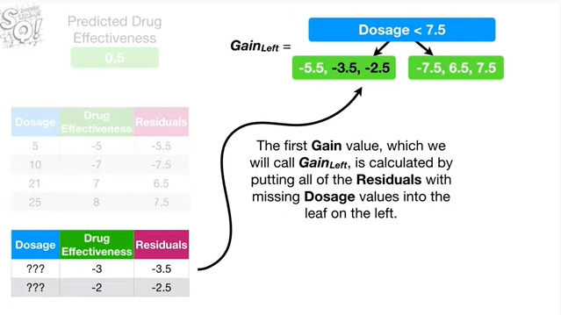

The first gain value, which we will call gain left, is calculated by putting all of the residuals with missing dosage values into the leaf on the left.

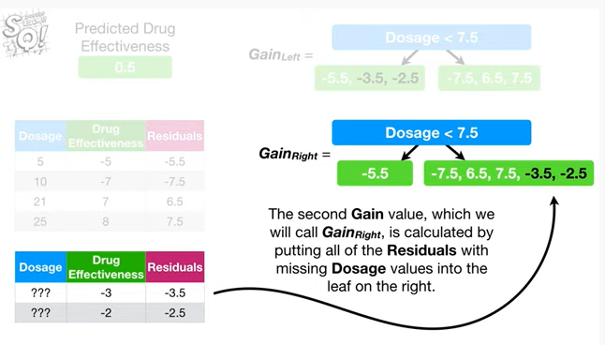

The second gain value, which we will call gain right, is calculated by putting all of the residuals with missing dosage values into the leaf on the right.

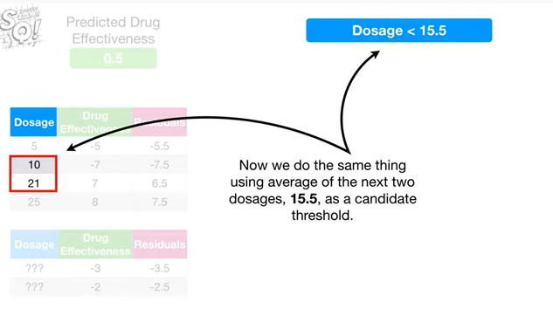

Now we do the same thing using the average of the next two dosages, 15.5, as a candidate threshold.

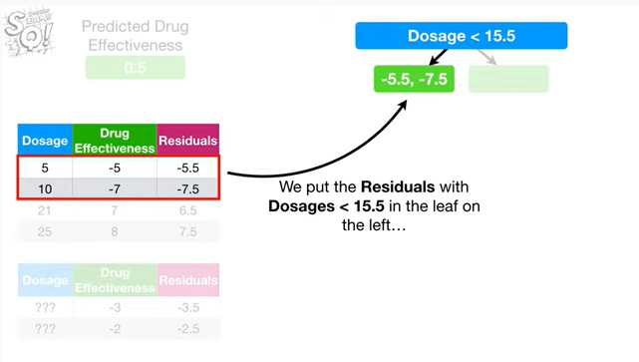

We put the residuals with dosages less than 15.5 in the leaf on the left

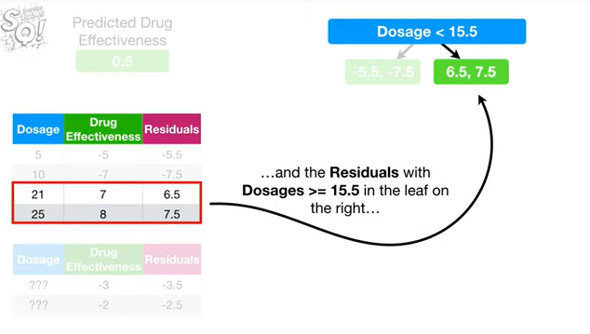

and the residuals with dosages greater than or equal to fifteen point five in the leaf on the right

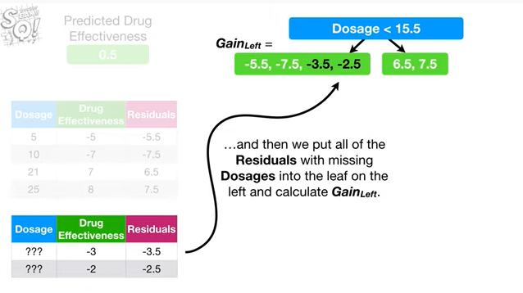

and then we put all of the residuals with missing dosages into the leaf on the left and calculate gain left.

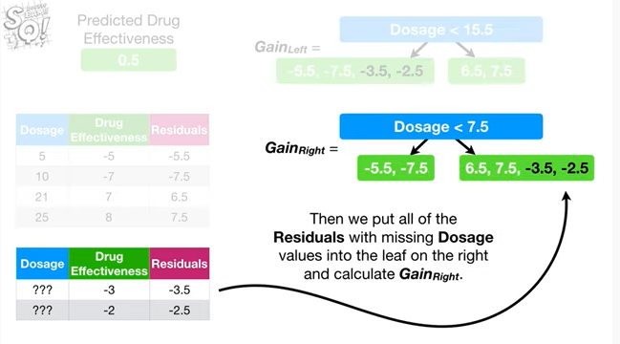

Then we put all of the residuals with missing dosage values into the leaf on the right and calculate gain right.

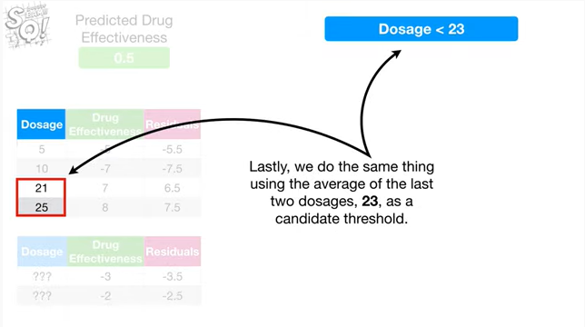

Lastly, we do the same thing using the average of the last two dosages 23 as a candidate threshold.

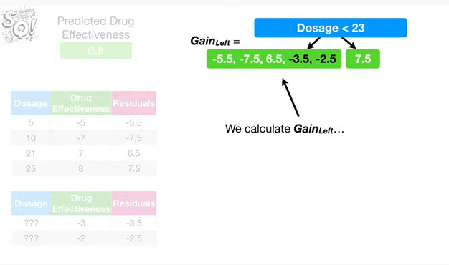

We calculate gain left

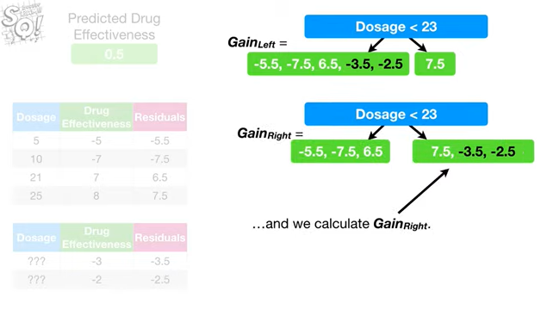

and we calculate gain right.

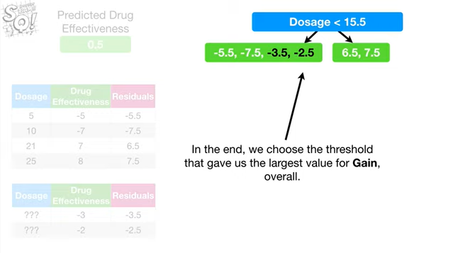

In the end, we choose the threshold that gave us the largest value for gain, overall.

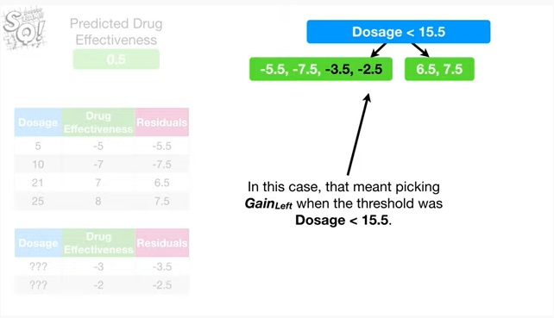

In this case, that meant picking gain left when the threshold was dosage less than fifteen point five.

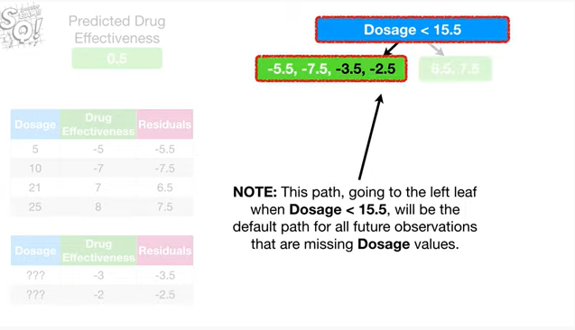

Note : this path, going to the left leaf when dosage is less than fifteen point five, will be the default path for all future observations that are missing dosage values.

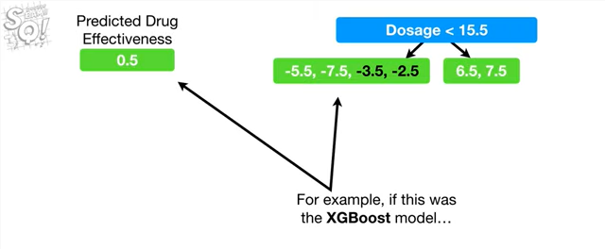

For example if this was the XGBoost model

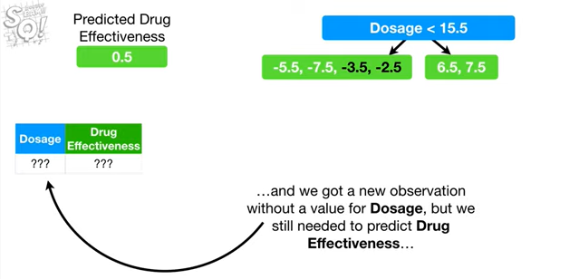

and we got a new observation without a value for dosage but we still needed to predict drug effectiveness

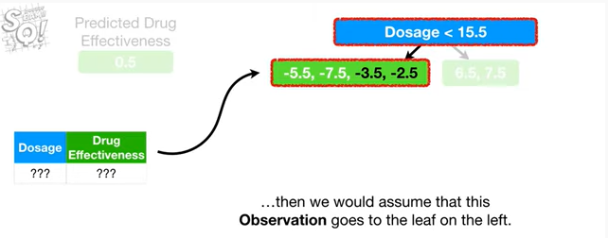

then we would assume that this observation goes to the leaf on the left.

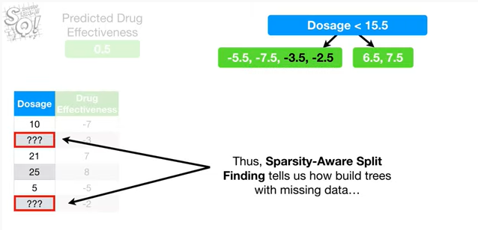

Thus, sparsity aware split finding tells us how to build trees with missing data

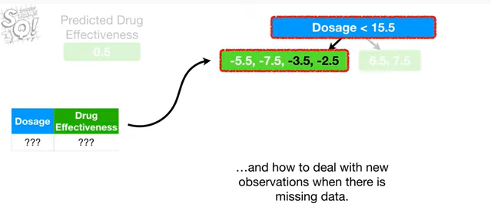

and how to deal with new observations when there is missing data.

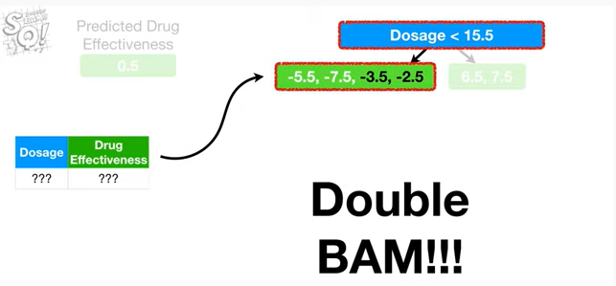

Double bam !!!

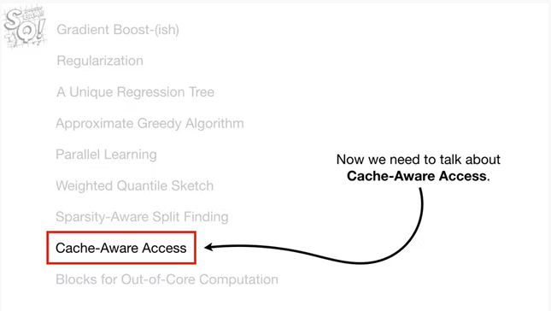

Now we need to talk about cache aware access.

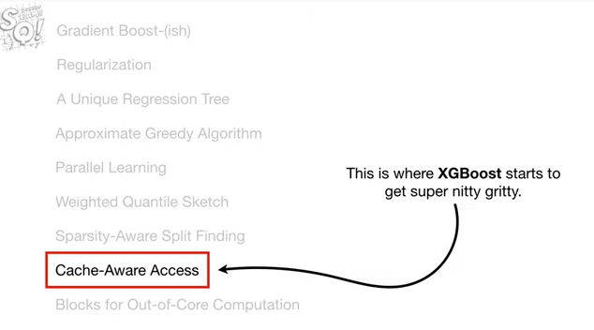

This is where XGBoost starts to get super nitty-gritty.

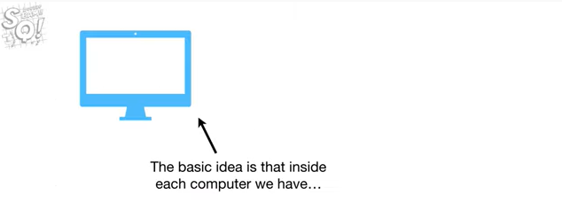

The basic idea is that inside each computer we have

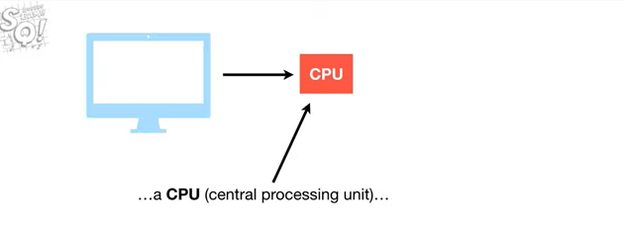

a CPU a central processing unit

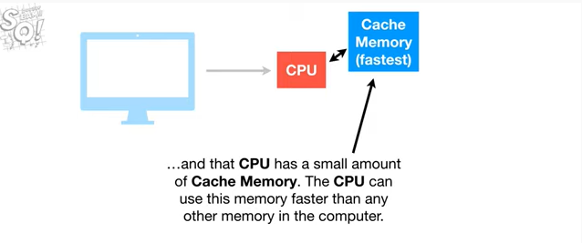

and that CPU has a small amount of cache memory.

The CPU can use this memory faster than any other memory in the computer.

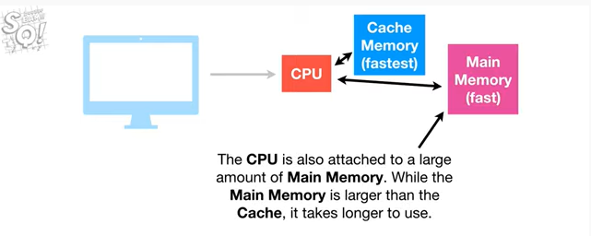

The CPU is also attached to a large amount of main memory.

While the main memory is larger than the cache, it takes longer to use.

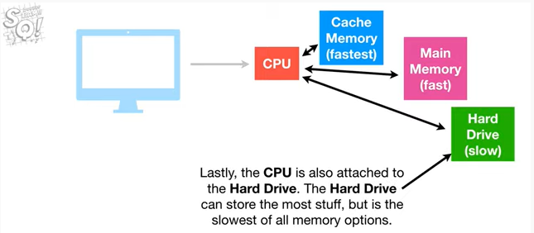

Lastly, the CPU is also attached to the hard drive.

The hard drive can store the most stuff, but is the slowest of all memory options.

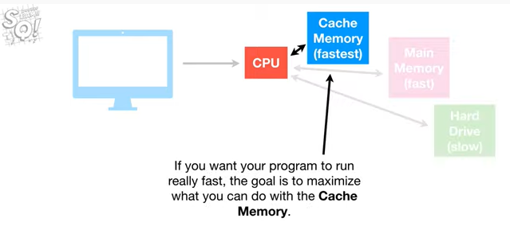

If you want your program to run really fast, the goal is to maximize what you can do with the cache memory.

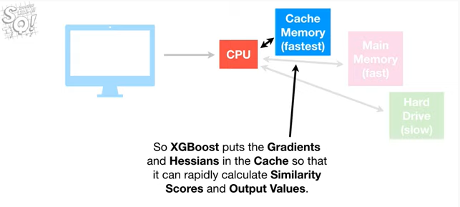

So XGBoost puts the gradients and Hessians in the cache so that it can rapidly calculate similarity scores and output values.

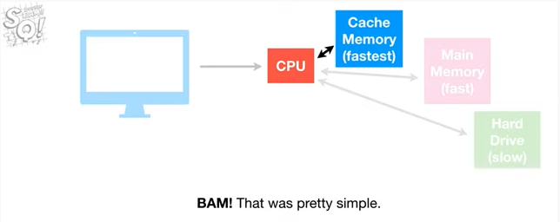

BAM !!!

That was pretty simple.

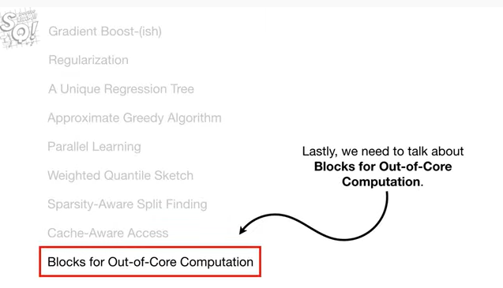

Lastly, we need to talk about blocks four out of core computation.

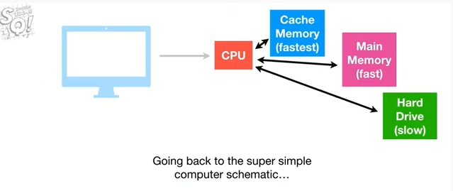

Going back to the super simple computer schematic.

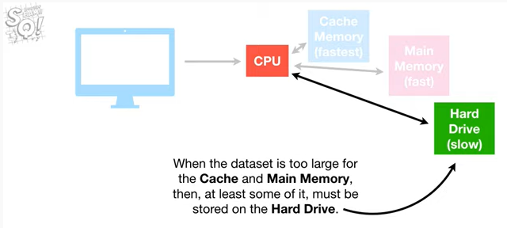

when the data set is too large for the cache and main memory, then, at least some of i,t must be stored on the hard drive.

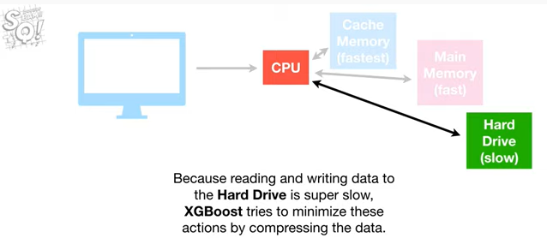

Because reading and writing data to the hard drive is super slow, XGBoost tries to minimize these actions by compressing the data.

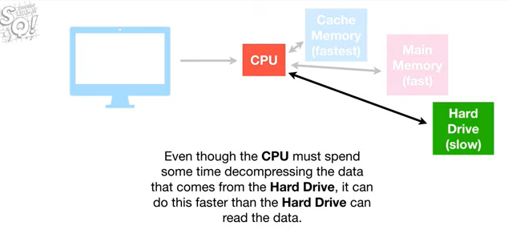

Even though the CPU must spend some time decompressing the data that comes from the hard drive, it can do this faster than the hard drive can read the data.

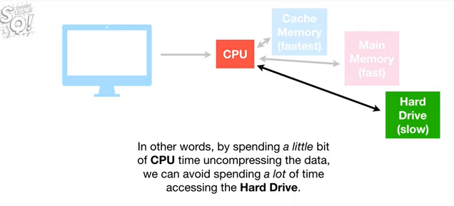

In other words, by spending a little bit of CPU time uncompressing the data, we can avoid spending a lot of time accessing the hard drive.

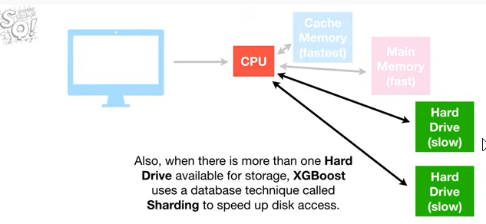

Also when there is more than one hard drive available for storage, XGBoost uses a database technique called sharding to speed up disk access.

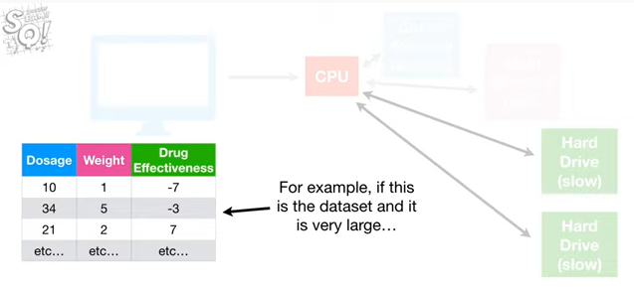

For example, if this is the data set and it is very large

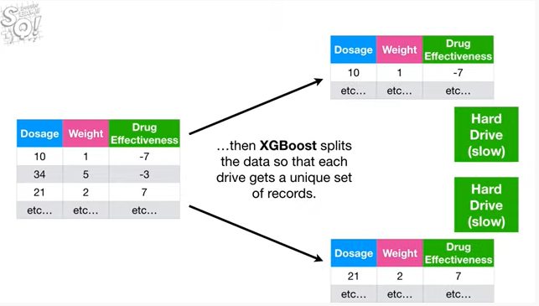

then XGBoosts splits the data so that each drive gets a unique set of records.

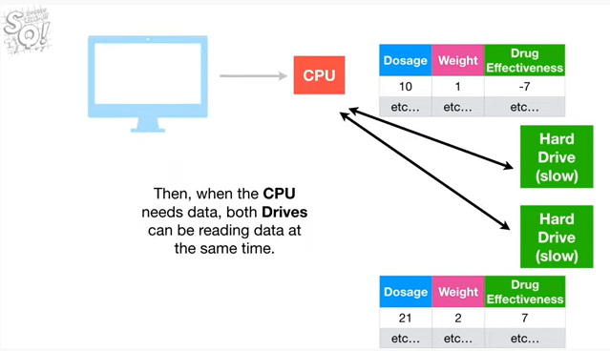

Then, when the CPU needs data, both drives can be reading data at the same time.

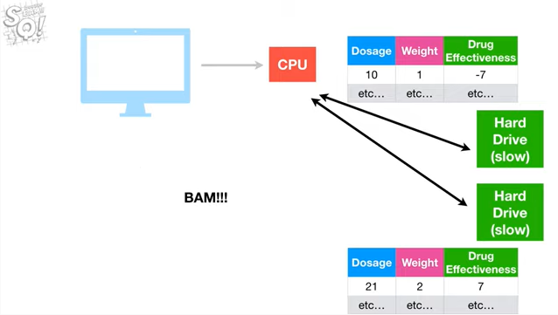

BAM !!!

Thus, Cache Aware access and blocks four out of core computation or optimizations that take the computer hardware into account.

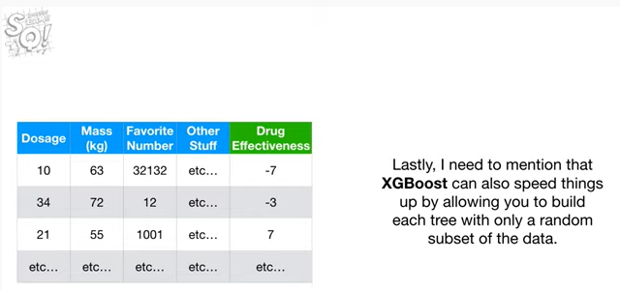

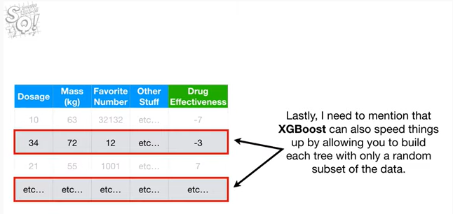

Lastly, I need to mention that XGBoost can also speed things up by allowing you to build each tree with only a random subset of the data.

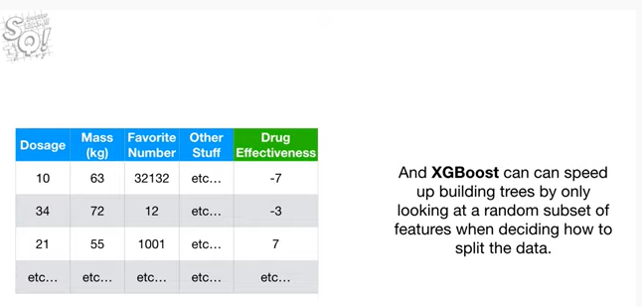

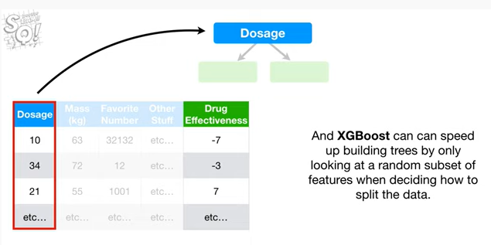

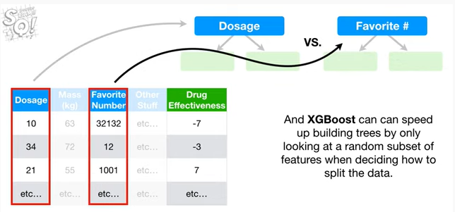

And XGBoost can speed up building trees by only looking at a random subset of features when deciding how to split the data.

BAM

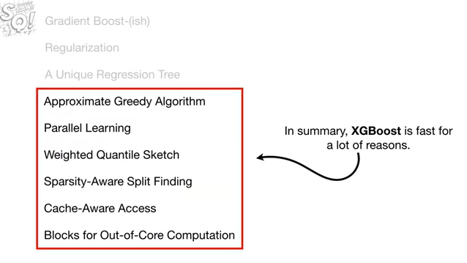

In summary, XGBoost is fast for a lot of reasons.

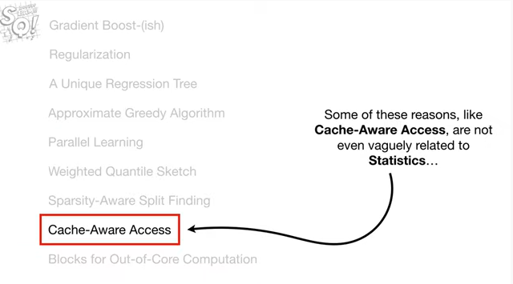

Some of these reasons, like cache-aware access, are not even vaguely related to statistics

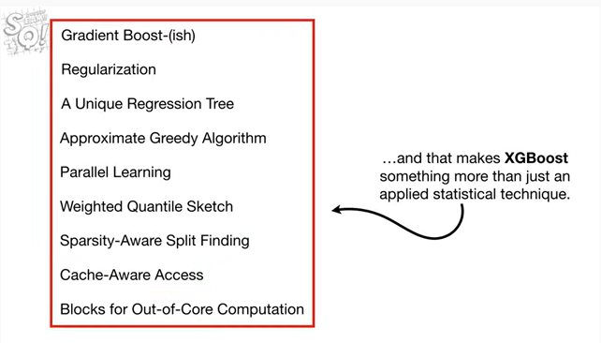

and that makes XGBoost something more than just an applied statistical technique.

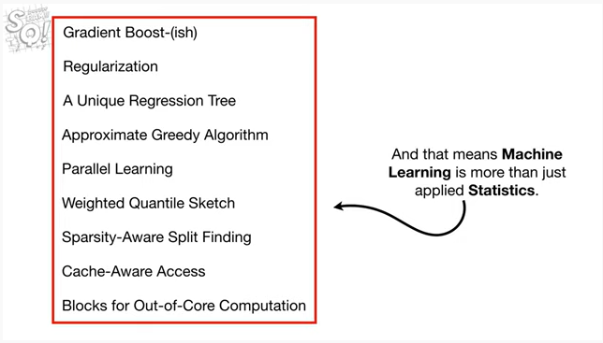

And that means machine learning is more than just applied statistics.

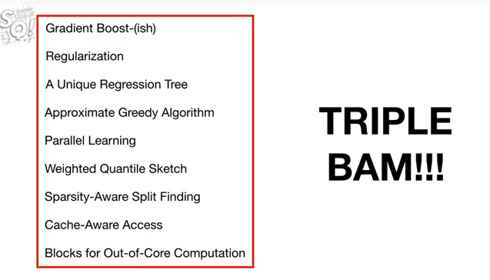

Triple bam !!!